A Guide for Classroom Discussion
December 2023

The guide for classroom use has been developed to assist faculty using slides to educate students on the Fundamental Pharmacists Responsibilities and Rights document developed by the American Pharmacists Association and the National Alliance of State Pharmacy Associations. These slides are divided into three sections: background information on the development of the document, a review of the principles, and scenarios that may be encountered. This guide is intended to stimulate discussion amongst student pharmacists as they consider pharmacy practice and employment opportunities.
The slides have extensive speaker notes that can be used to familiarize faculty with the topic.

Learning Objectives

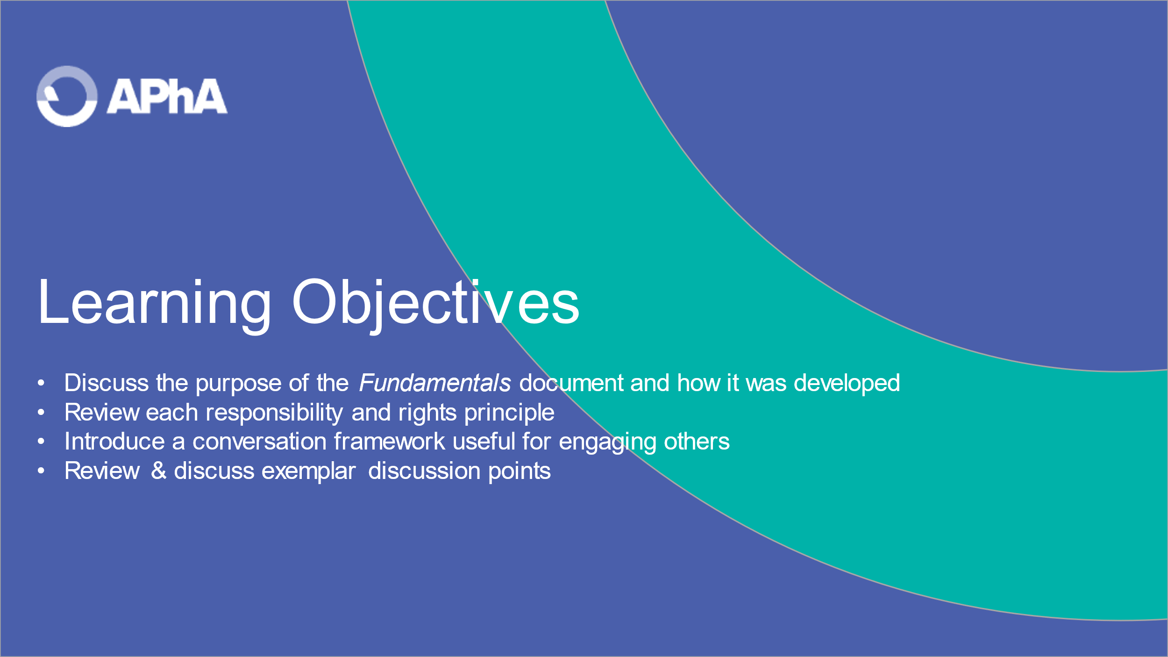
Review the four sections of the presentation with the learner.

SECTION 1. OVERVIEW & PURPOSE

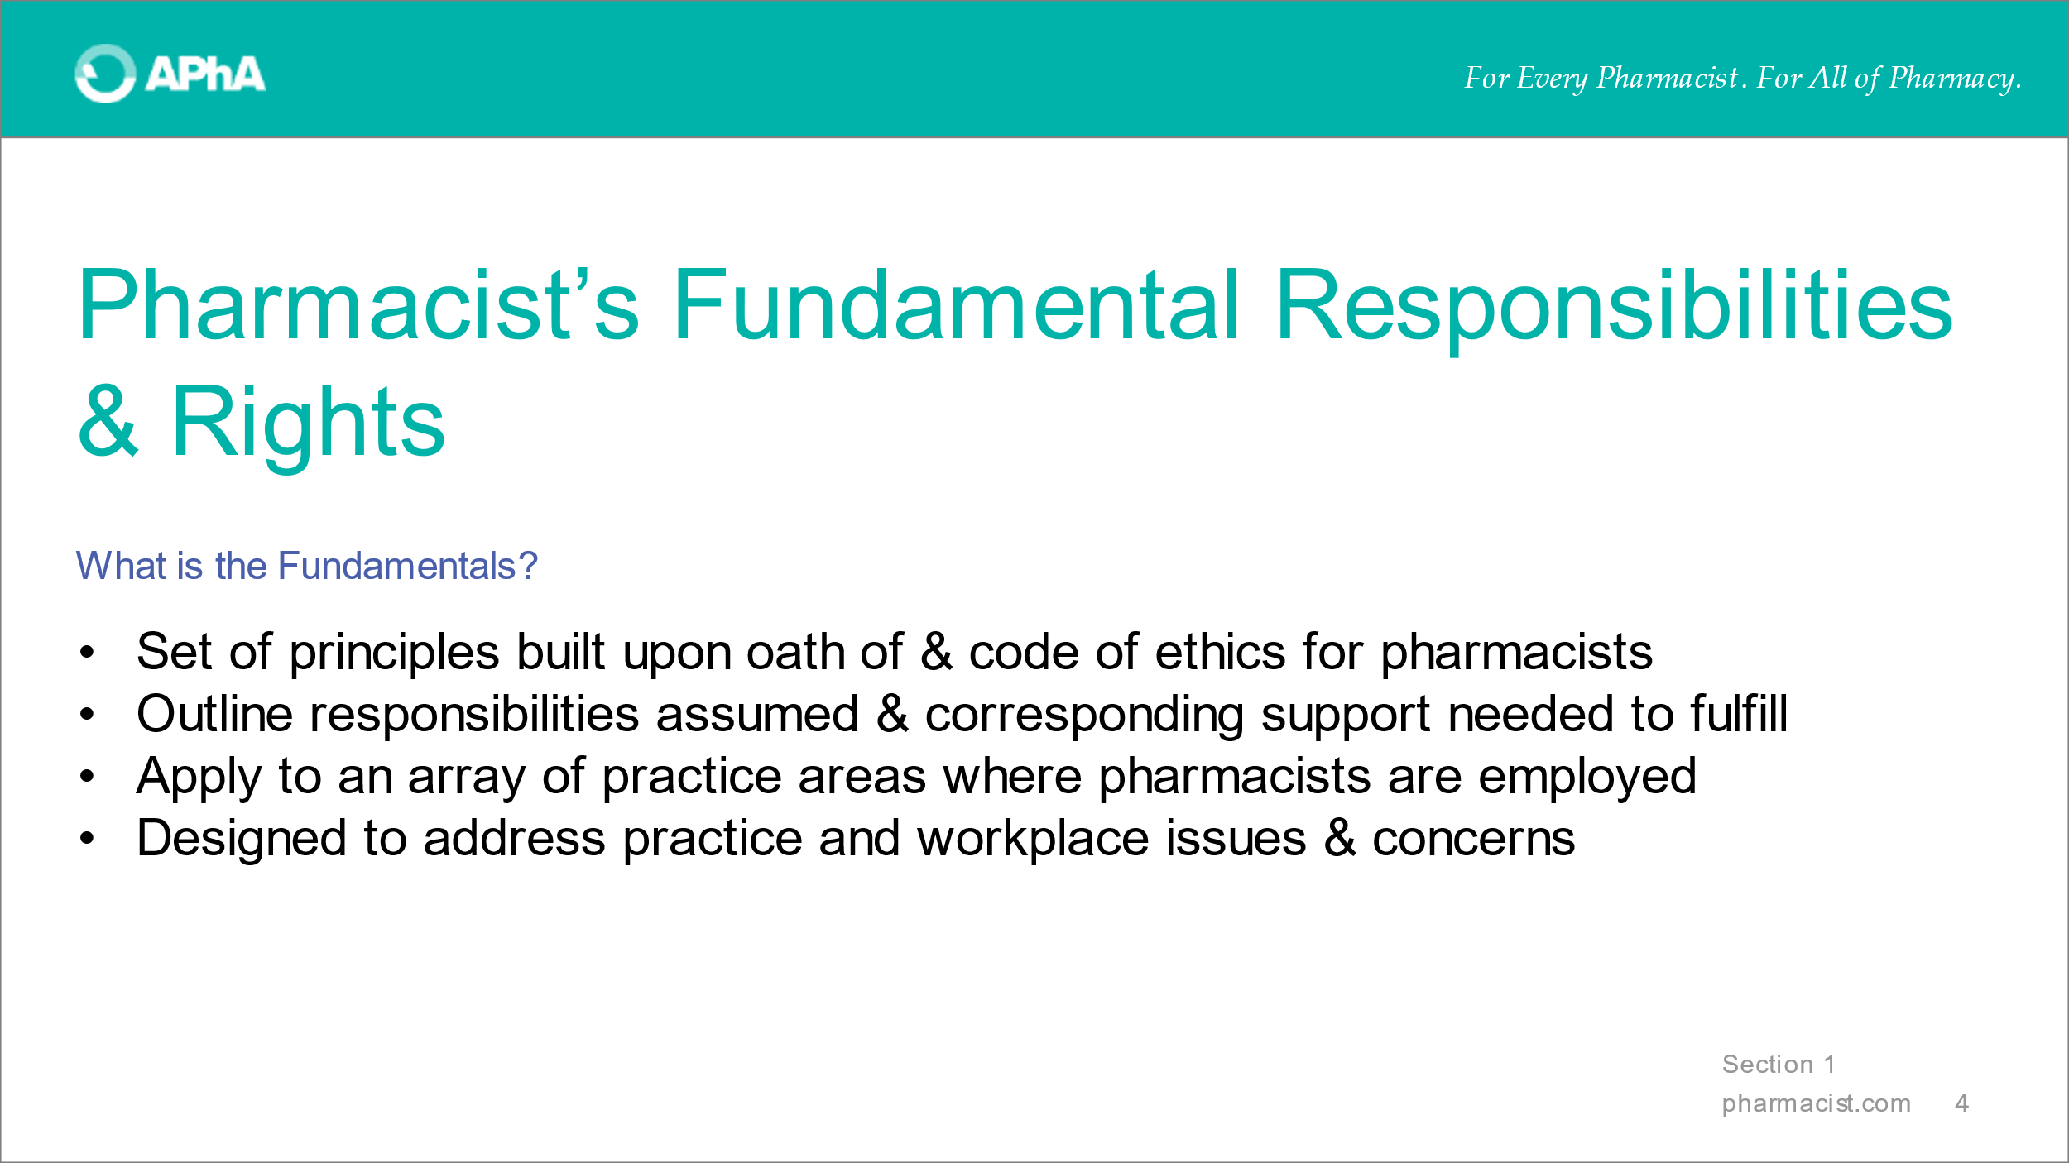
Start by reviewing that the document is a set of principles for which pharmacists declare [to the public] for what they are responsible and what is needed so that responsibilities can be fulfilled. The Fundamentals are one tool for pharmacists to use to start a meaningful dialogue about their practice and workplace concerns.

These principles apply broadly to practice areas and not a specific practice area.

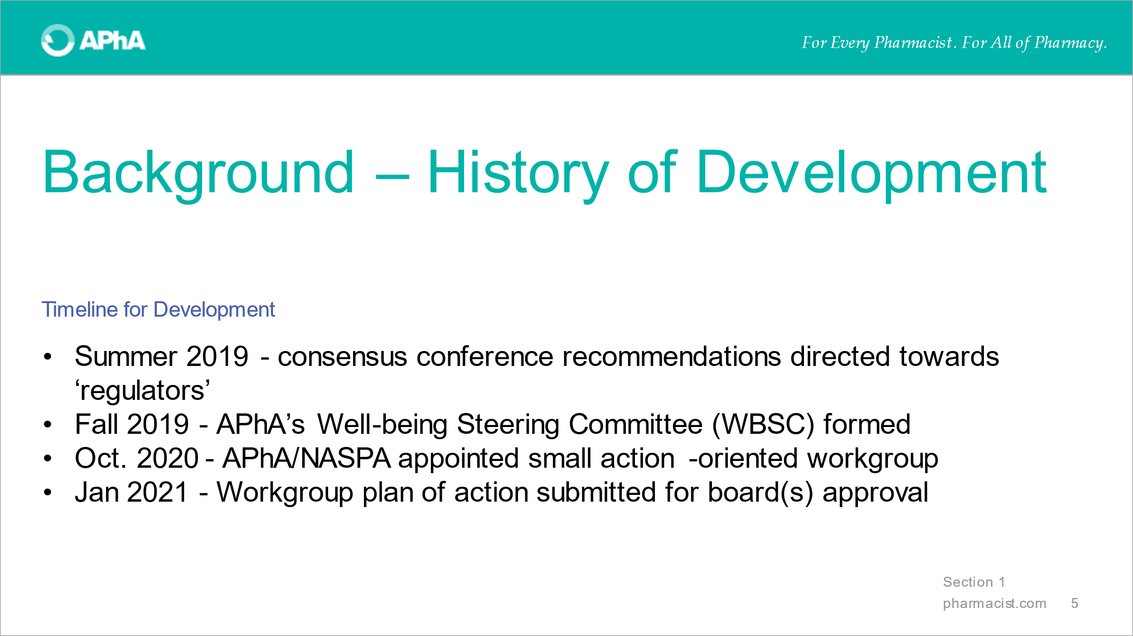
Review the timeline for development. The key point here is that activity in this area to advance practice environments has been occurring for years.

The small, action-oriented workgroup was productive and created a suite of impactful tools, giving life to consensus conference statements.
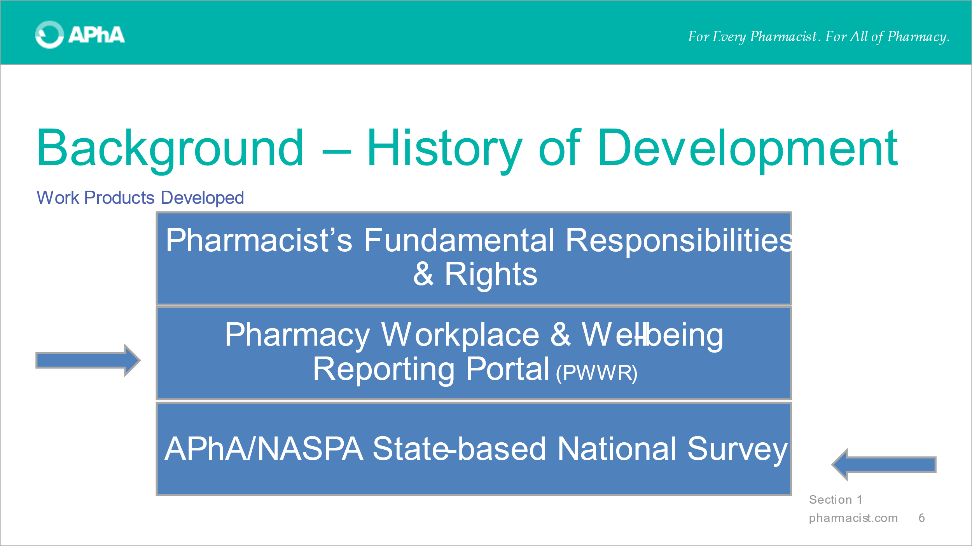
Review the two other items developed in the suite of tools developed to impact workplace environments.

Additional information about these tools can be found at pharmacists.com/wellbeing.

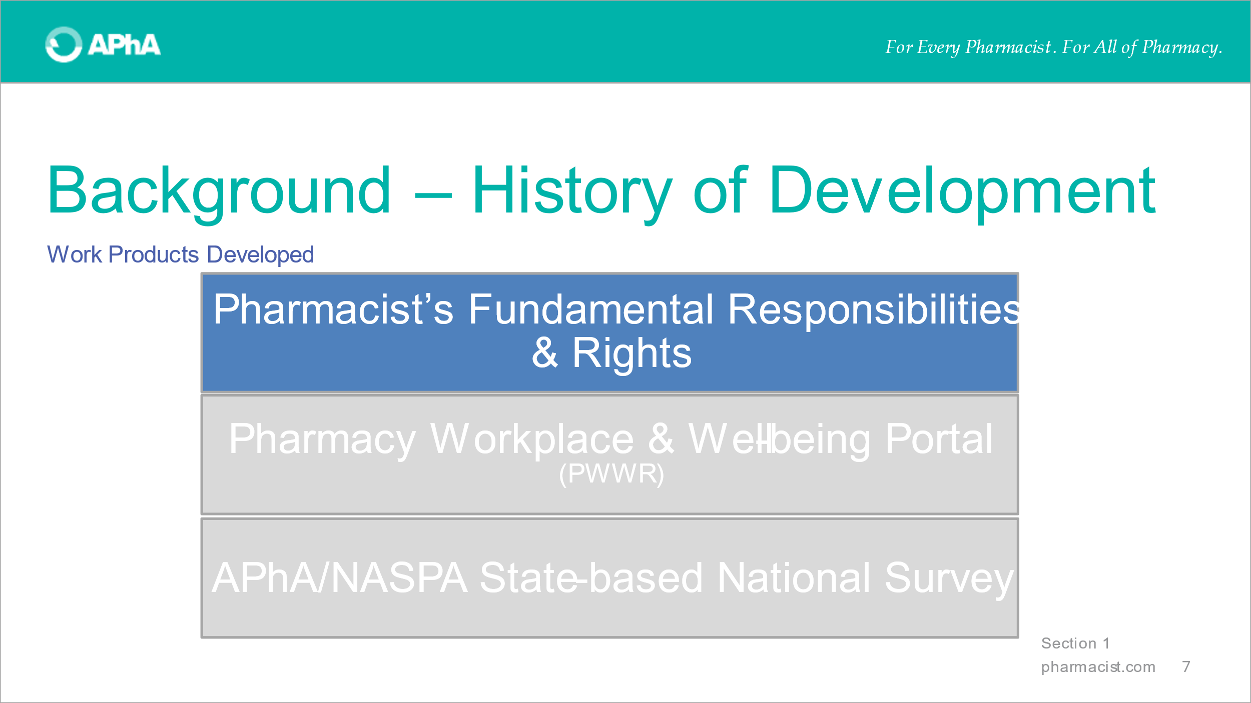
Narrow the focus upon the Pharmacist’s Fundamental Responsibilities and Rights. Note that the order of the words is intentional to emphasize that pharmacists are professionals responsible for delivery of patient care. In order to successfully fulfill these responsibilities, adequate support of certain rights is required.
Responsibilities first, supported by rights!

SECTION 2. RESPONSIBILITIES AND RIGHTS PRINCIPLES
Section 2a. Fundamental responsibilities
With a copy of the Fundamentals readily available, review the first responsibility.

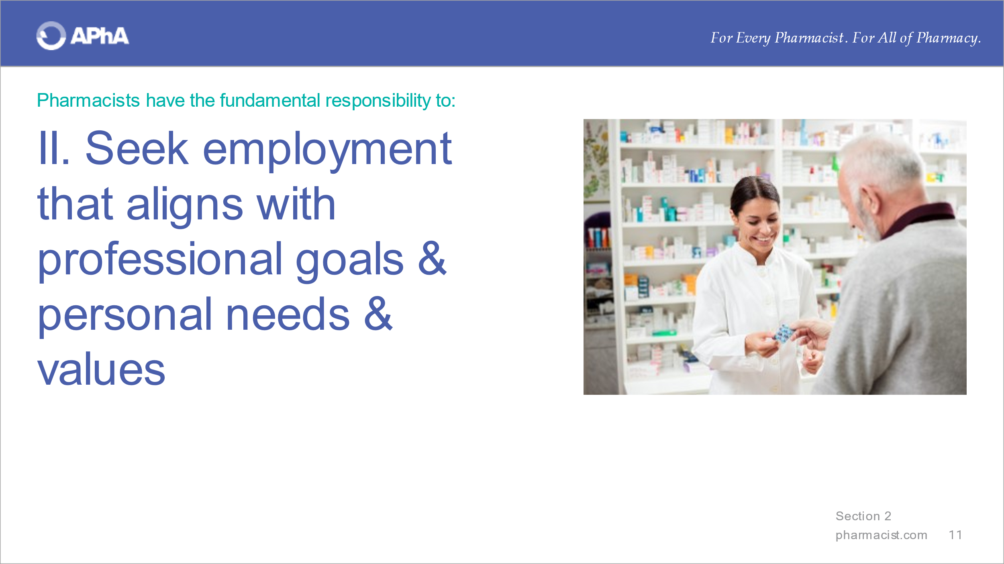
With a copy of the Fundamentals readily available, review the second responsibility. Emphasize that this responsibility is one where the most influence can be exerted by students. Pharmacists and student pharmacists are best positioned to make informed decisions at the outset of an employment opportunity. Use speaker notes here or defer them to Section 4.

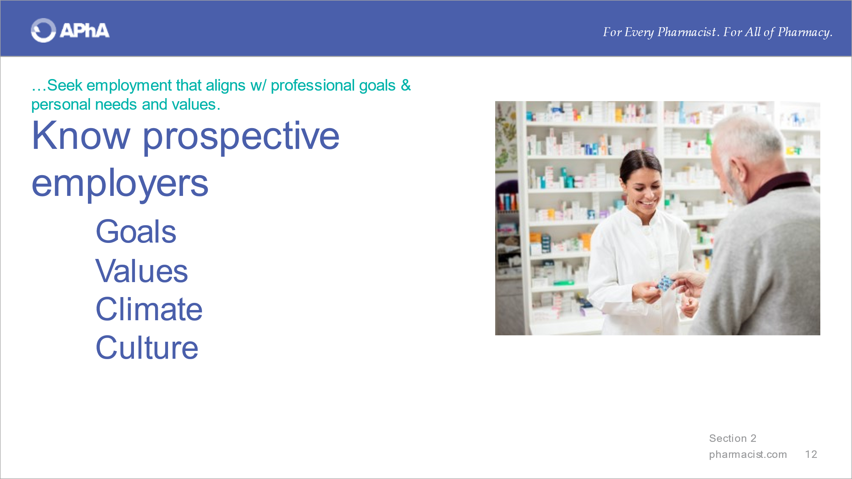
Equally worth emphasizing is the fact that student pharmacists and pharmacists must know about the prospective employer – they are empowered to know as much as they can. In a sense, they are interviewing the organization as much as they are being interviewed.

Questions to ask appear in Section 4. You can also engage learners to develop their own questions as a ‘workshop’ exercise.

With a copy of the Fundamentals readily available, review the third responsibility.

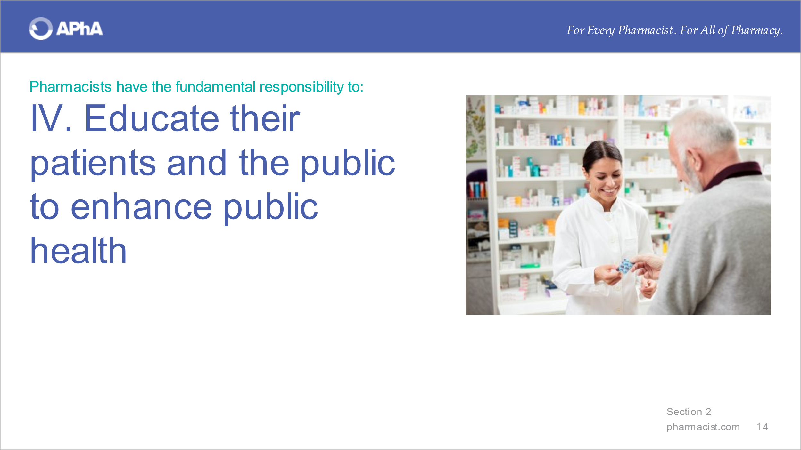
With a copy of the Fundamentals readily available, review the fourth responsibility.
More than ever, the visibility of pharmacists has expanded. Pharmacists and pharmacy personnel are essential in a variety of work settings in every community.

With a copy of the Fundamentals readily available, review the fifth responsibility.

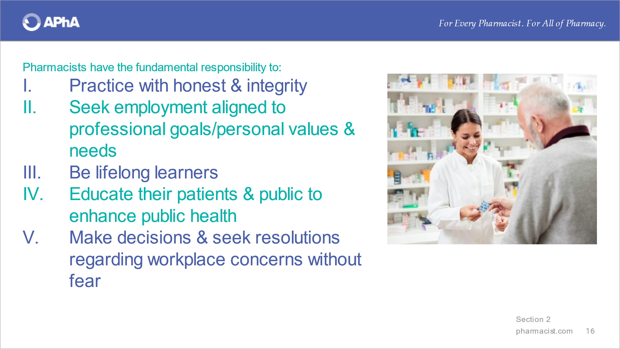
Summarize this section by emphasizing that the five principles represent the publicly stated responsibility that pharmacists strive to fulfill as they work to improve patient outcomes. They can guide pharmacists in entering relationships with employers, patients, and other health professionals and those responsible for establishing laws, regulations, and guidance governing care delivery by pharmacists.

Section 2b. Fundamental rights
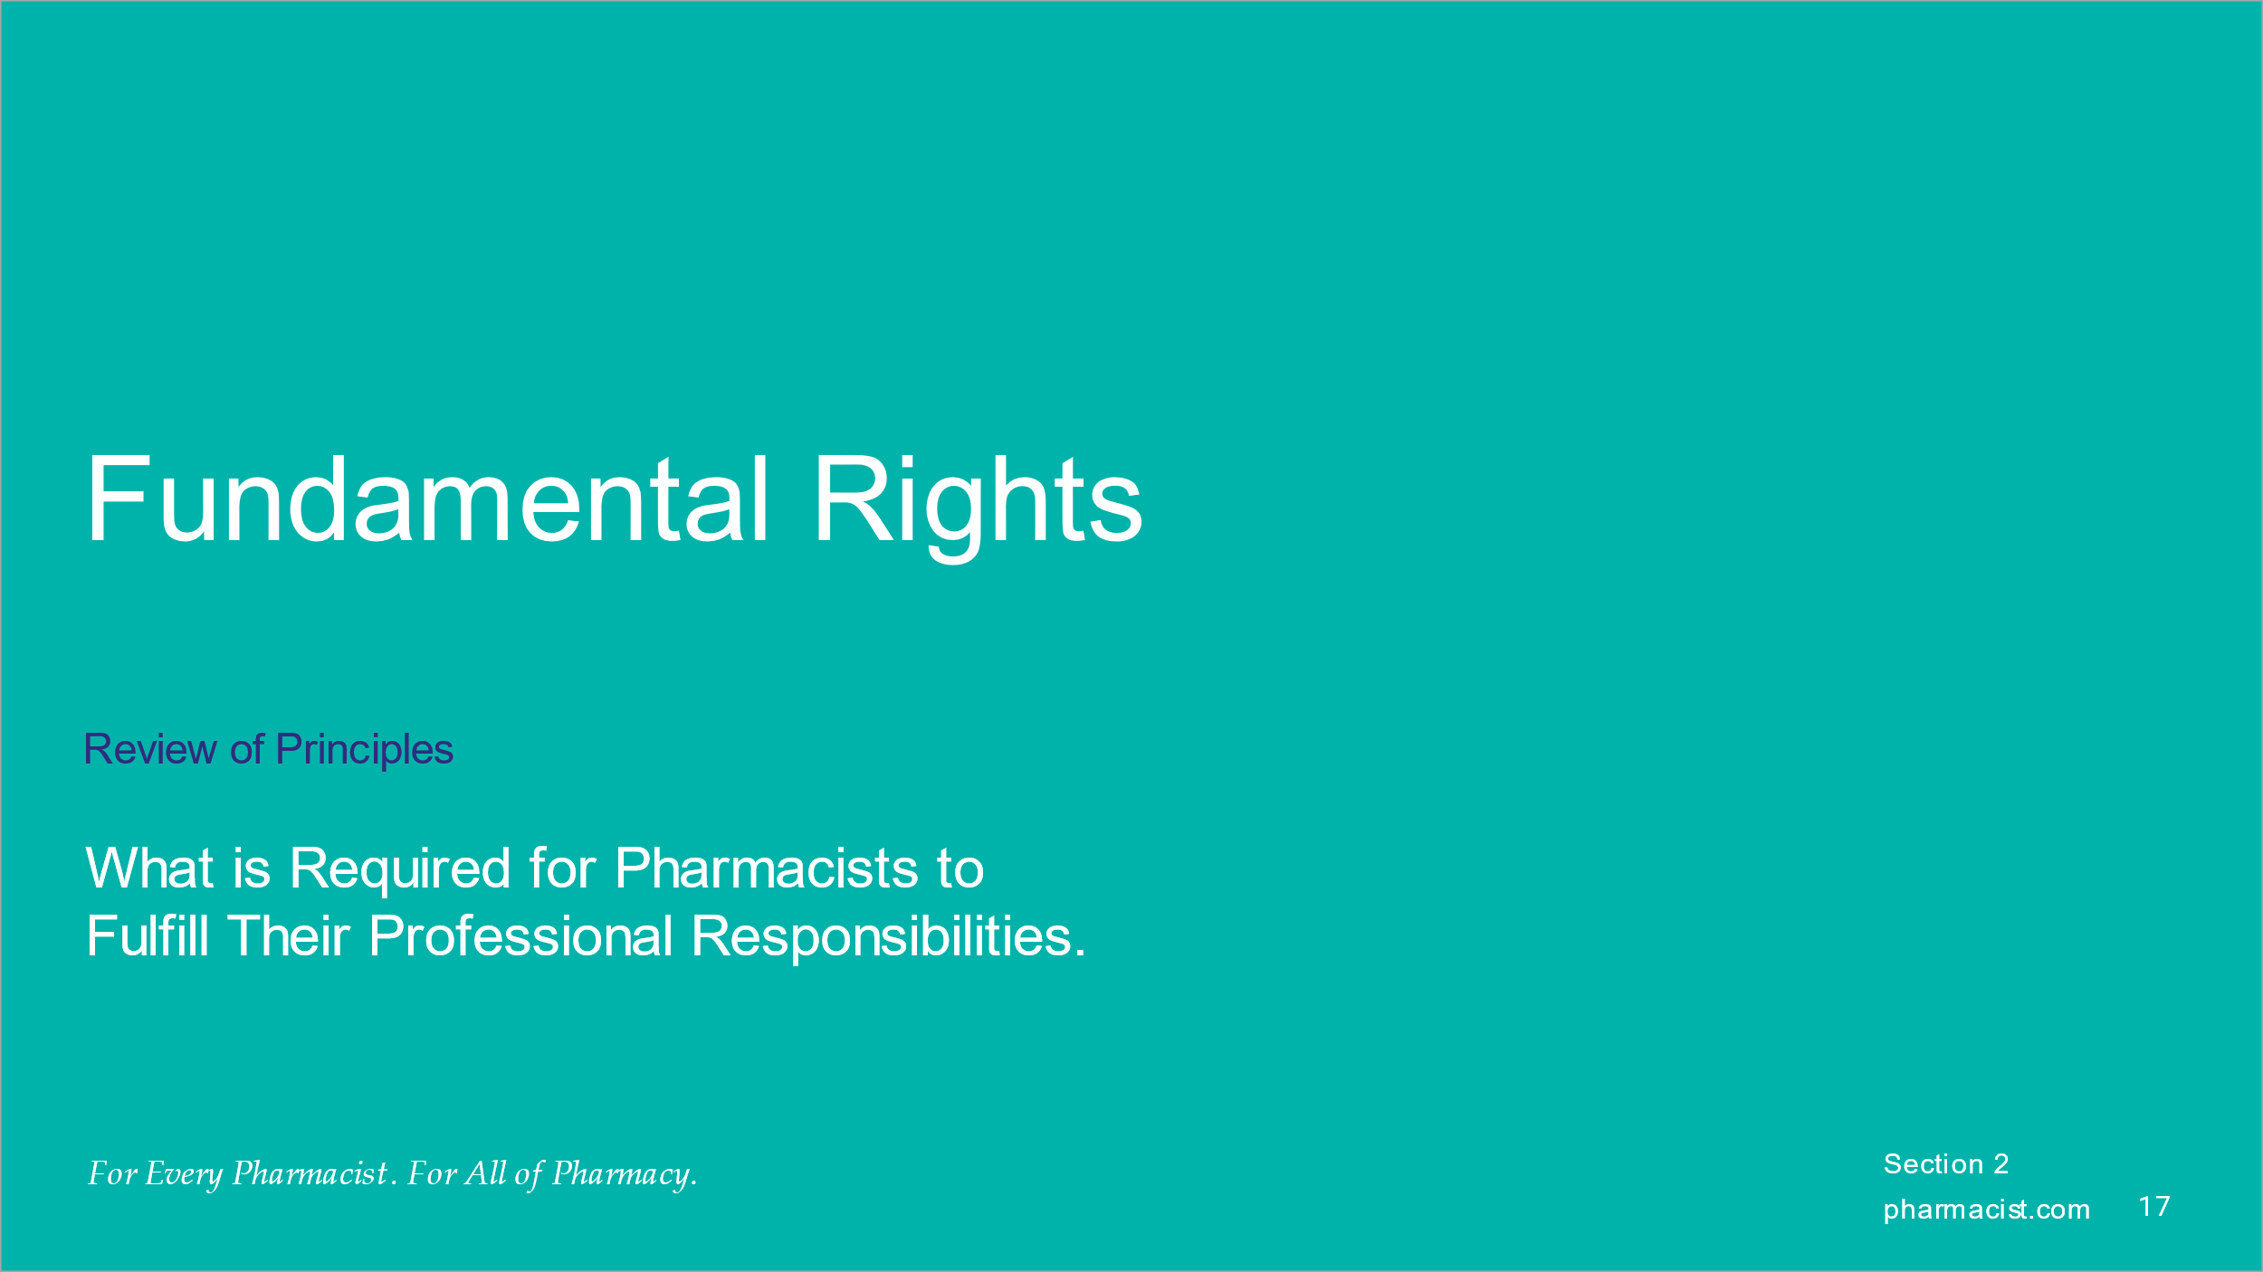
Pivot attention to review the fundamental rights.
The corresponding ‘rights’ are named and publicly communicated to describe what is needed in terms of support to enable the fulfillment of pharmacist professional responsibilities. Without appropriate and adequate support, pharmacist professional responsibility fulfillment will be suboptimal or not possible.

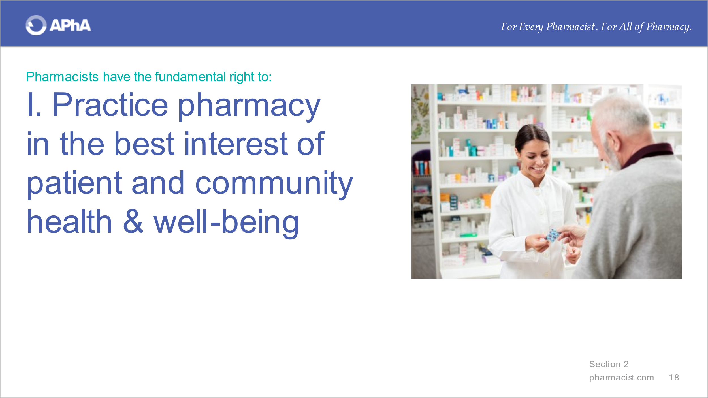
With a copy of the Fundamentals readily available, review the first right.

With a copy of the Fundamentals readily available, review the second right.

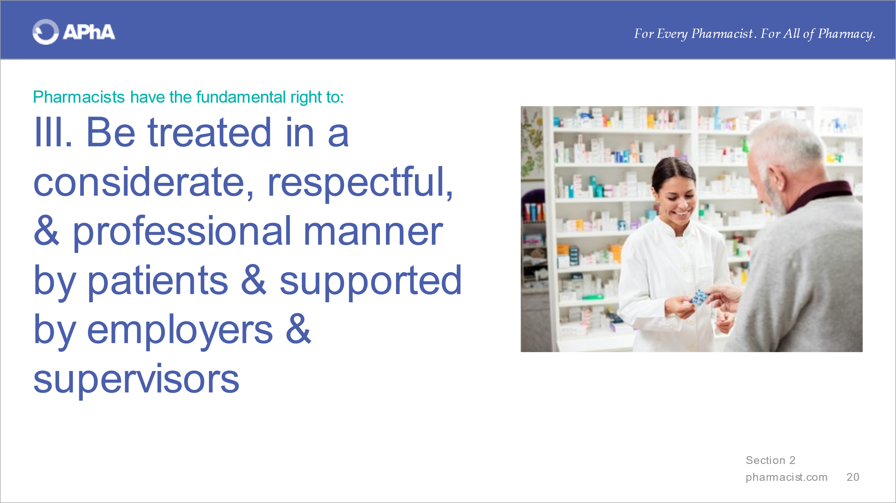
With a copy of the Fundamentals readily available, review the third right.

With a copy of the Fundamentals readily available, review the fourth right.

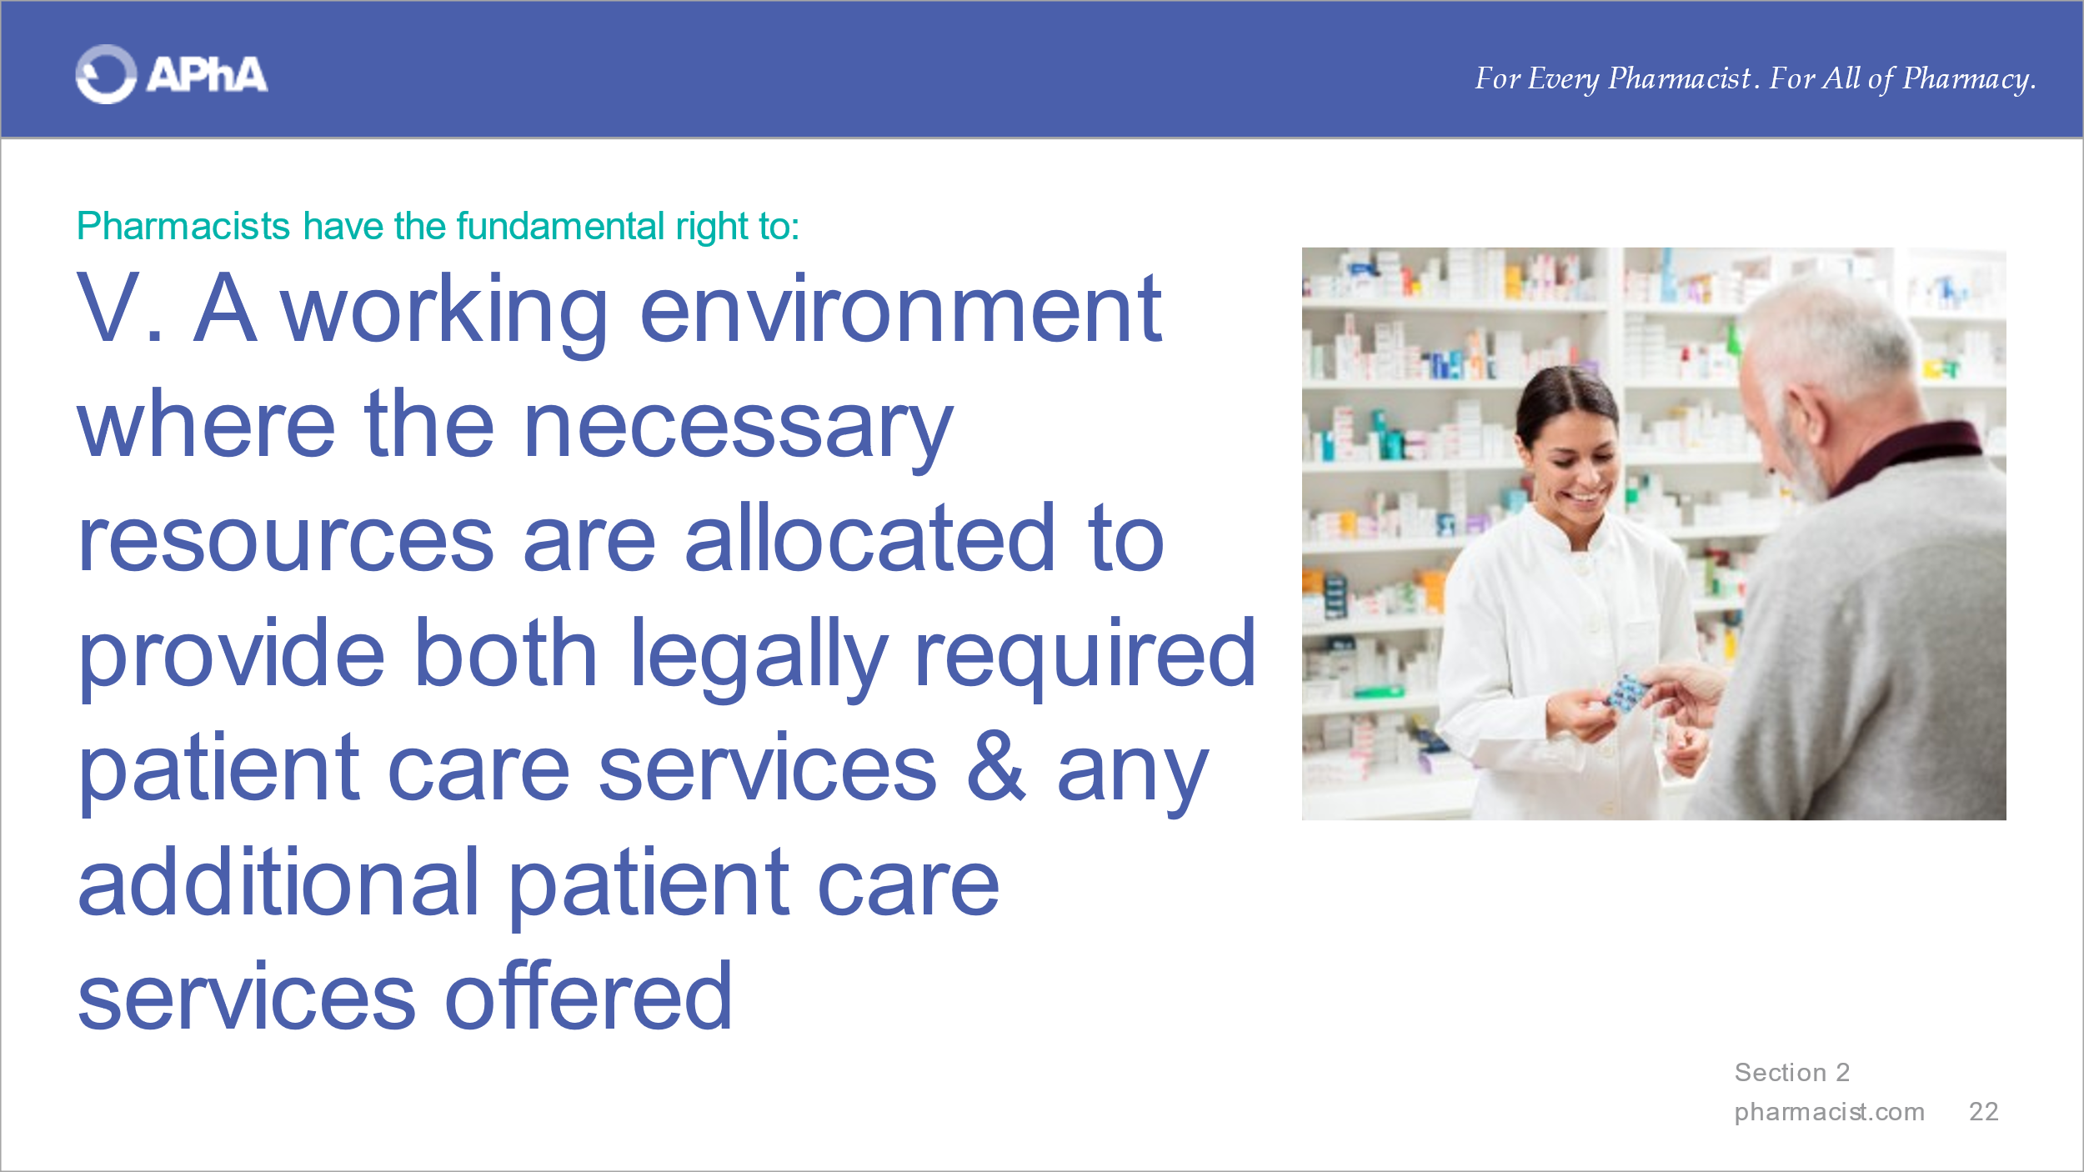
With a copy of the Fundamentals readily available, review the fifth right.

With a copy of the Fundamentals readily available, review the sixth right.

With a copy of the Fundamentals readily available, review the seventh right.
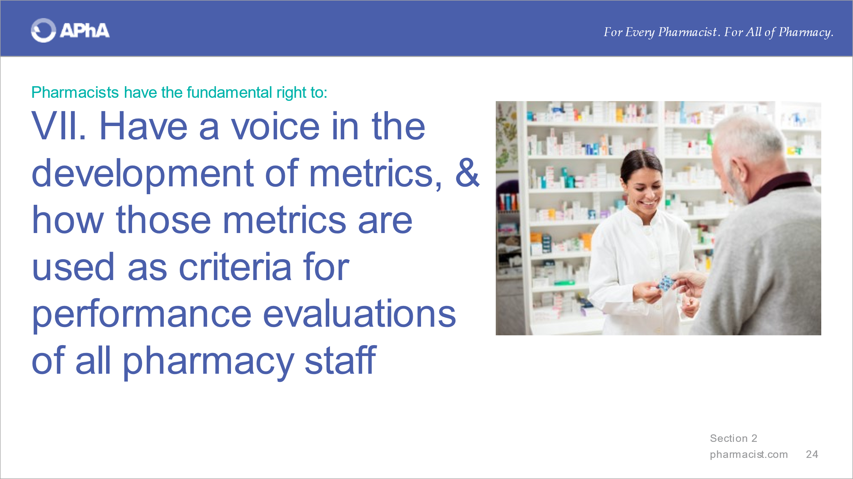

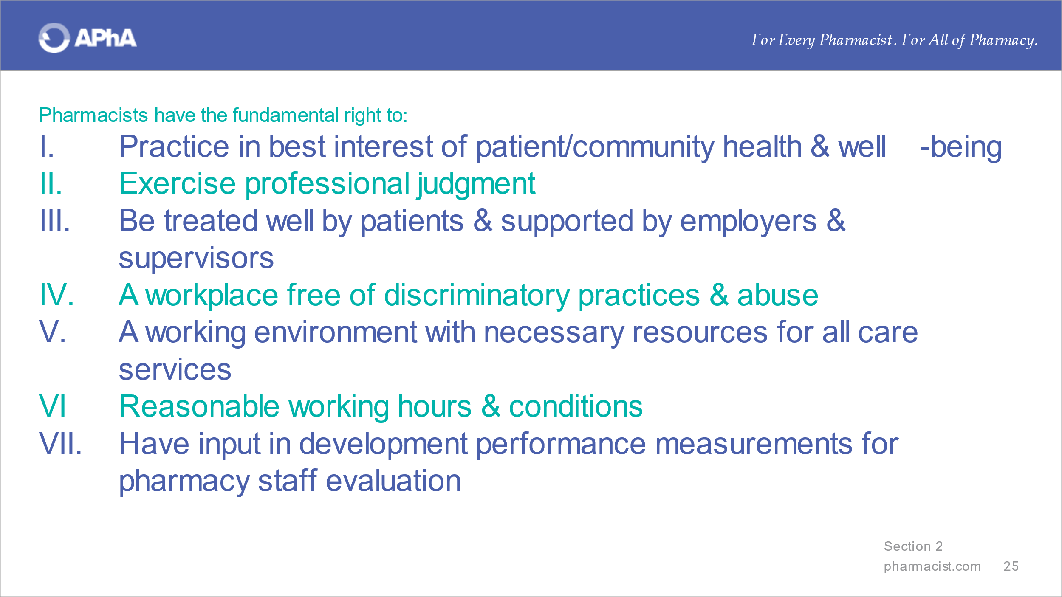
Summarize this section by emphasizing that the seven principles represent the publicly stated support that pharmacists need to fulfill their professional responsibilities. They can guide pharmacists in entering relationships with employers, patients, and other health professionals and those responsible for establishing laws, regulations, and guidance governing care delivery by pharmacists.

SECTION 3. OVERVIEW OF CONVERSATION STARTER

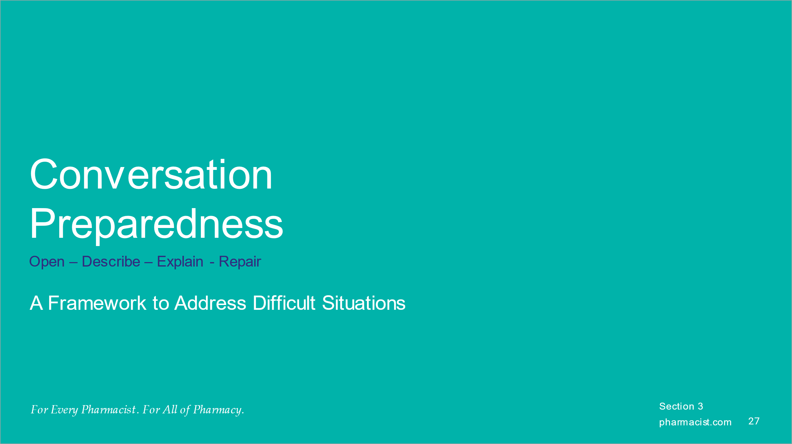
Emphasize that advocating for and addressing the principles contained in the Fundamentals is not an easy feat and requires preparation and courage. Discussions do not need to be confrontational and are rarely productive if they are. Planning what to say to kickstart and navigate the discussion can offer a sense of assertiveness and control.

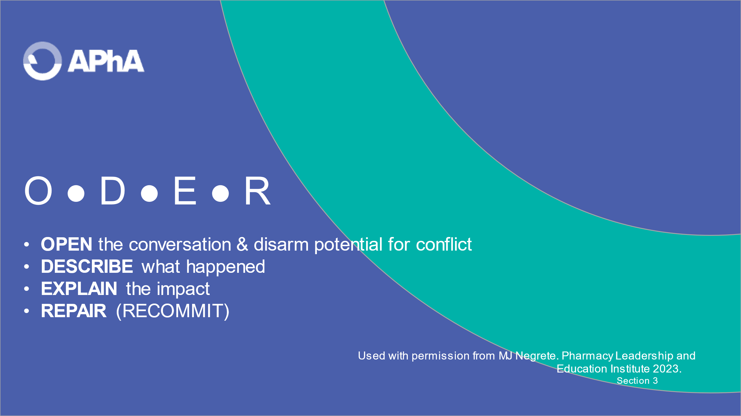
Introduce the ODER framework, which is a useful approach when a breakdown has occurred – amongst a pair of individuals or within a team - to address them directly and move through them.

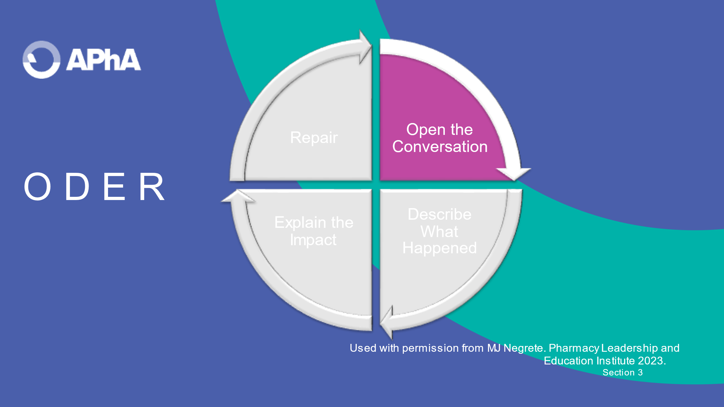
Review ‘Open the Conversation’ and the example to illustrate the step. Feel free to insert an example that fits the step.
Extending an invitation to meet at the convenience of the other person can mitigate the development of a defensive stance from the other person.

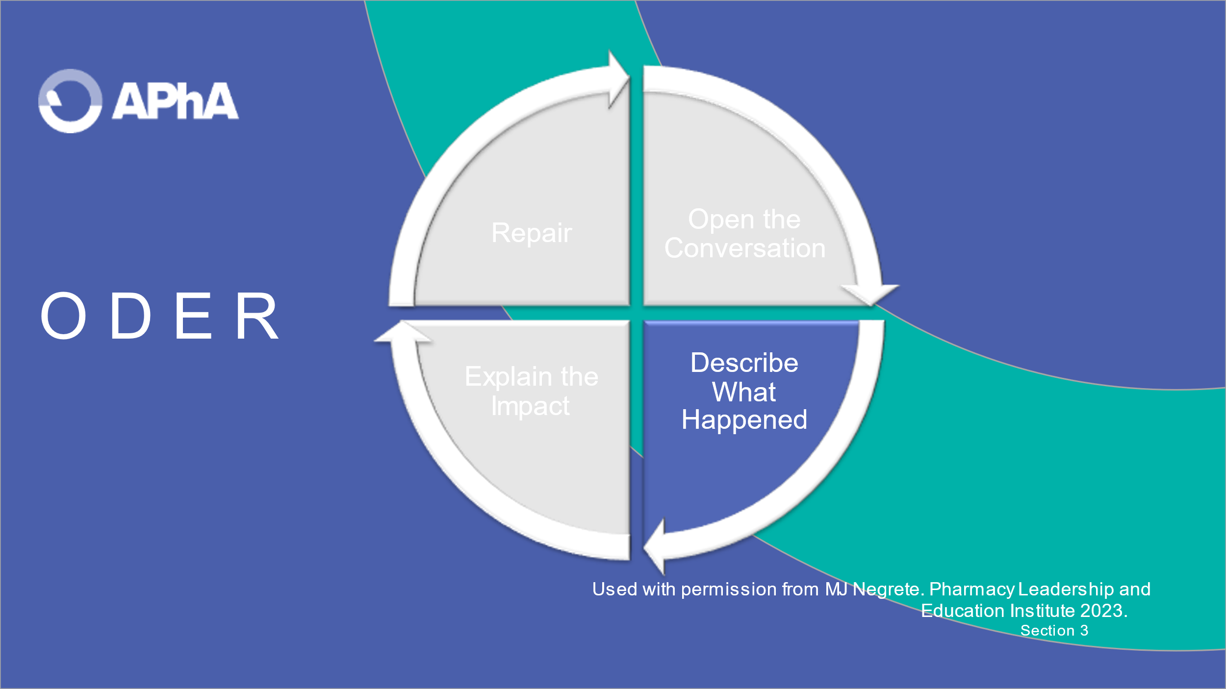
Review ‘Describe What Happened’ and the example to illustrate the step. Feel free to insert an example that fits the step.
The key to this step is to be as objective as possible when describing the situation.

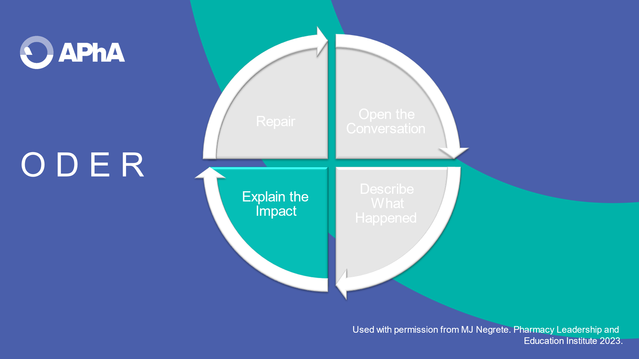
Review “Explain the Impact” and the example to illustrate the step. Feel free to insert an example that fits the step.

This step communicates the consequence(s) of not following through on what was agreed upon – the outcome of breakdown.

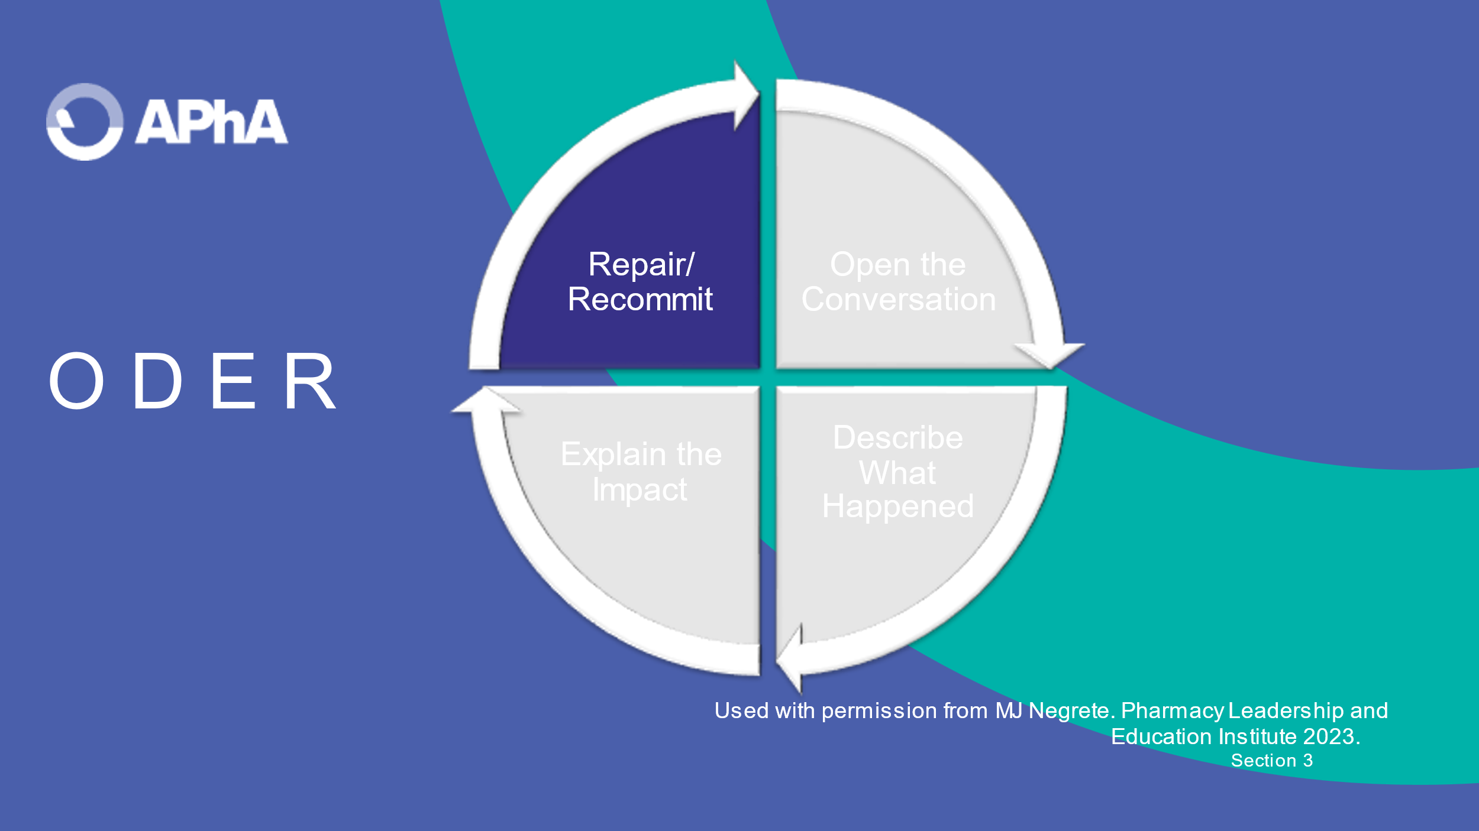
Review ‘Repair/Recommit’ and the example to illustrate the step. Feel free to insert an example that fits the step.

Repair involves a sincere apology and determination of what it will take to right the wrong. Recommit involves determining what can now be agreed upon to move forward.

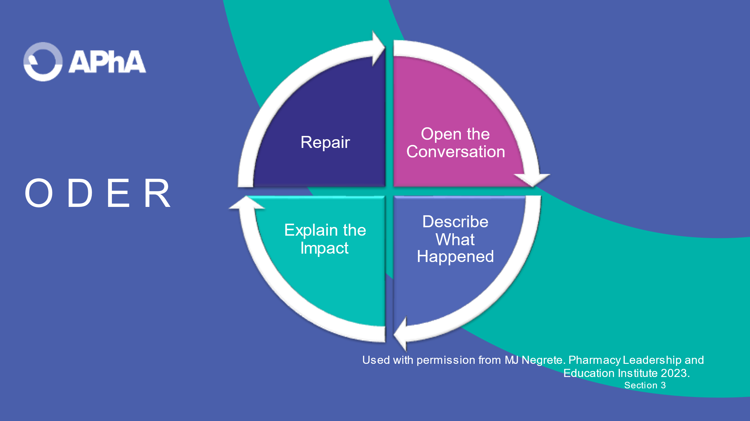
Summarize the ODER framework and emphasize the importance of preparing for a difficult conversation.

SECTION 4. EXEMPLARS FOR DISCUSSION
In this section, there are examples to stimulate discussion. The Fundamentals are only as good as its use to help individuals engage in conversations when they are being violated in some fashion. These scenarios are only a start and faculty encouraged to develop additional ones.

Scenario #1: “Mr. Carmichael was informed that his opioid prescription would be ready in 10 minutes after needed clarification from the prescriber was received only 10 minutes ago. The pharmacist noticed the patient has sleep apnea and may not tolerate the opioid increase. He had been notified as a courtesy via text that clarification was sought, and a delay was possible. Mr. Carmichael was enraged at the 10-minute delay. The store manager apologized for the pharmacist’s actions.

This scenario maps to Fundamental Right III.

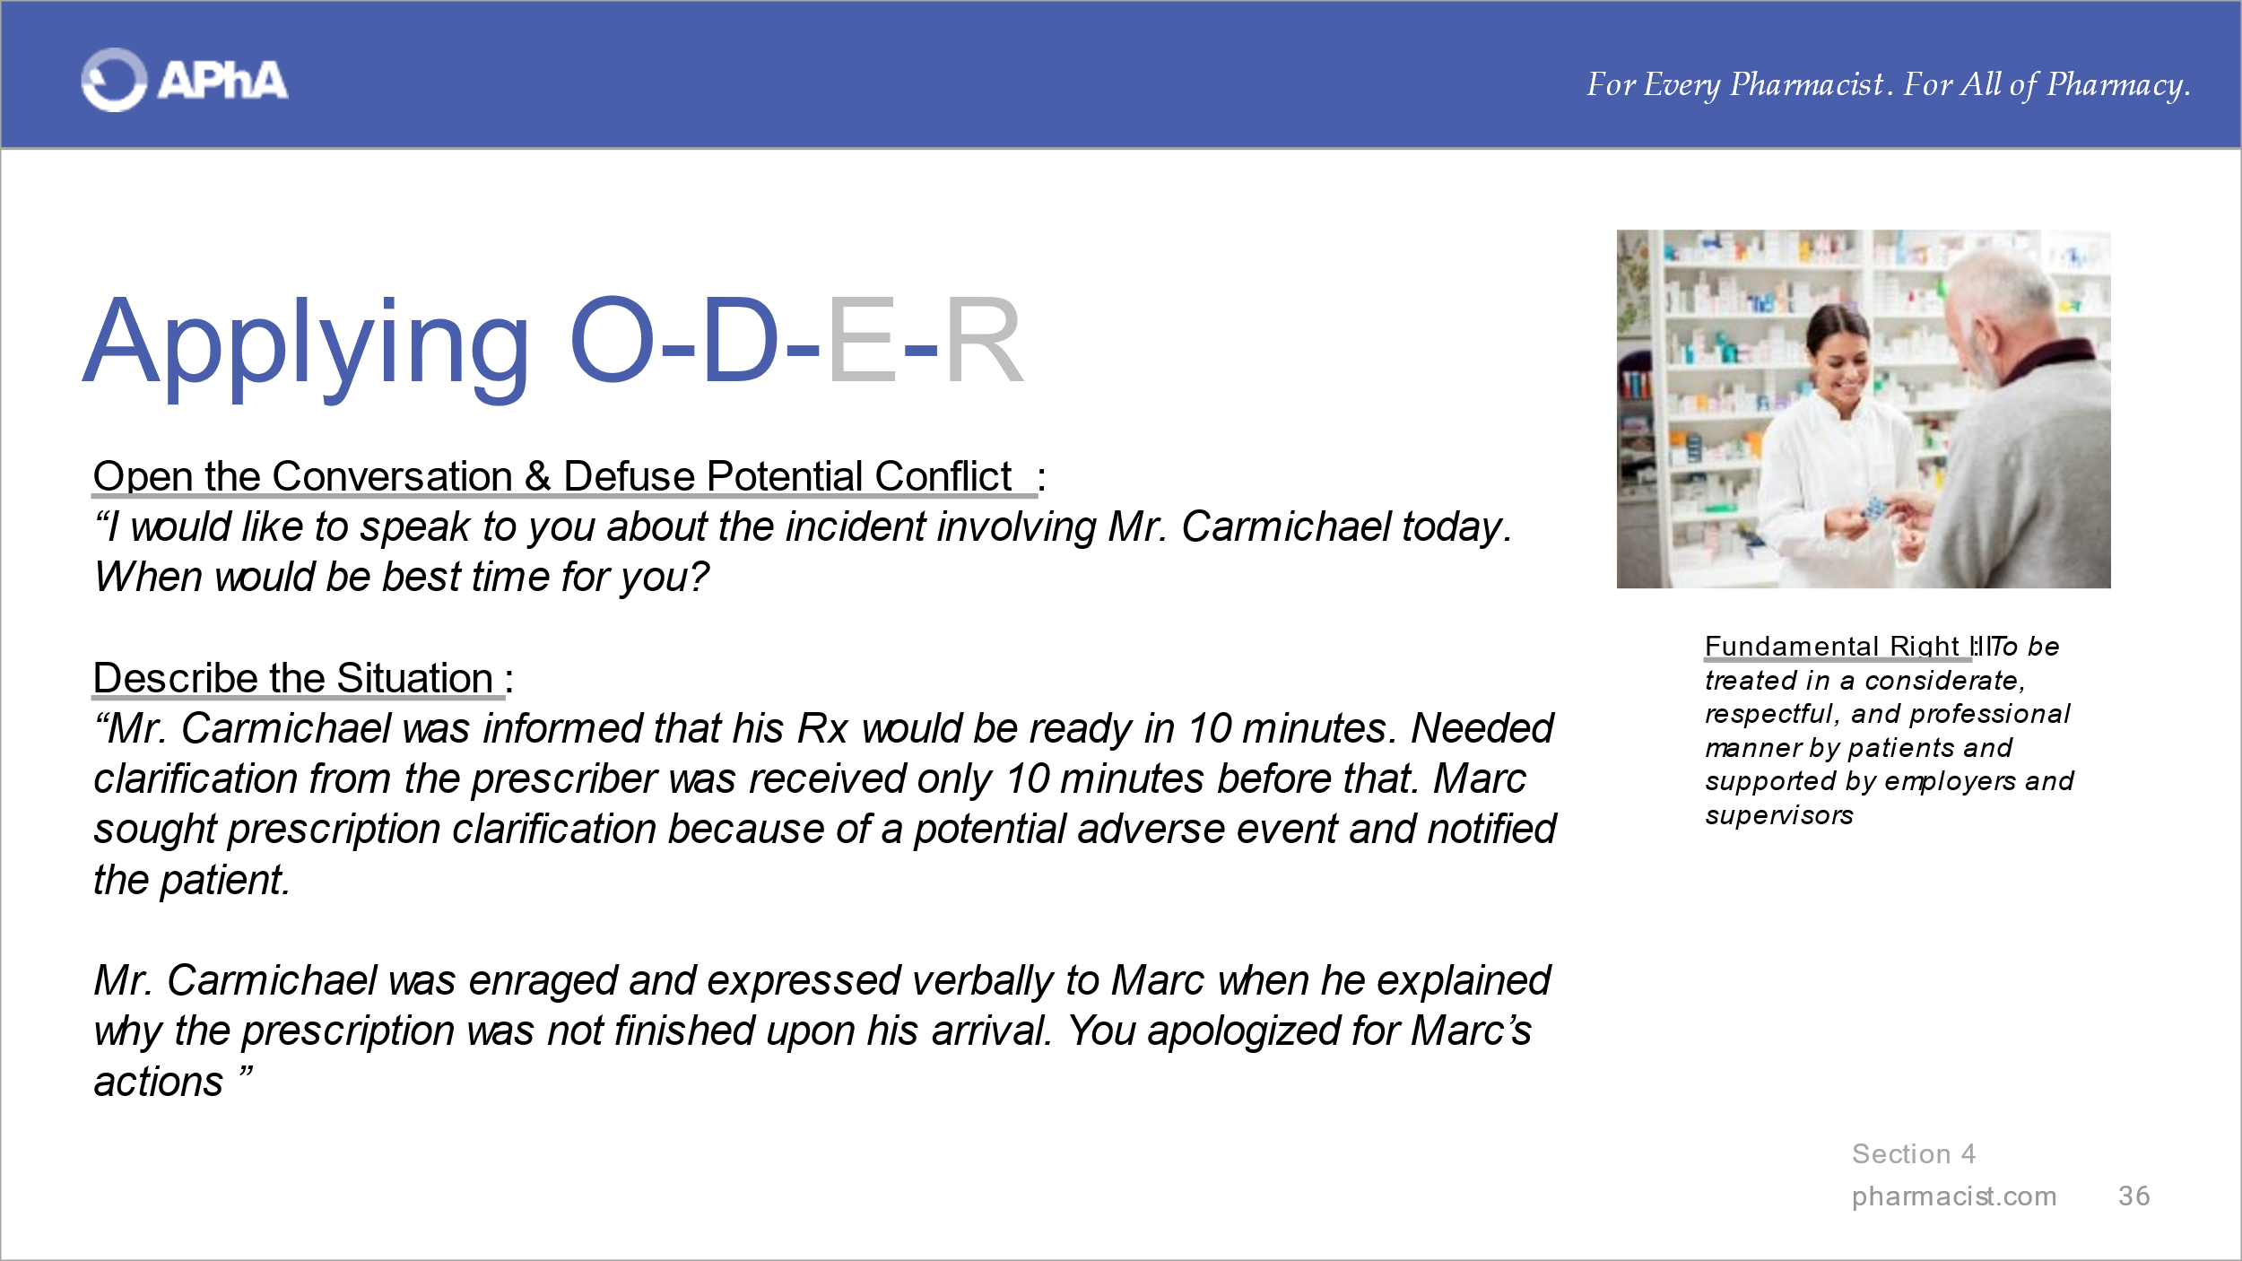
Introduce the first scenario and offer the example language to ‘Open the Conversation’ and ‘Describe the Situation’.

Ask whether learners can relate to this situation. Solicit alternatives to the example language offered for these two steps from learners.

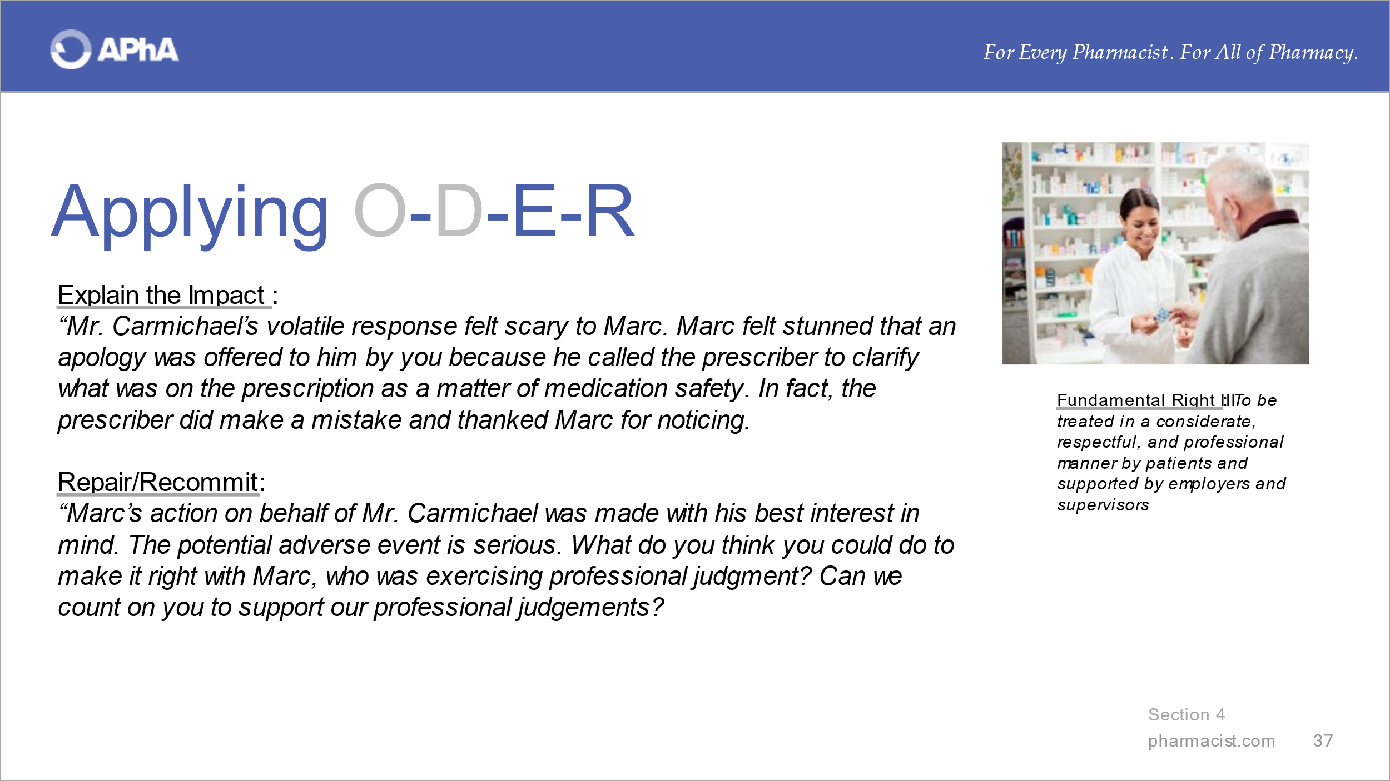
Offer the example language to illustrate ‘Explain the Impact’ and ‘Repair/Recommit’.

Solicit alternatives to the example language offered for these two steps from learners. Inquire whether learners feel that this situation maps to other responsibilities/rights and why.

Scenario #2: “The state association in conjunction with the local health department wishes to distribute naloxone through community pharmacies. A community pharmacy has signed up to participate in the program. There is concern amongst pharmacy personnel about the added workload.”

This scenario maps to Fundamental Right V.

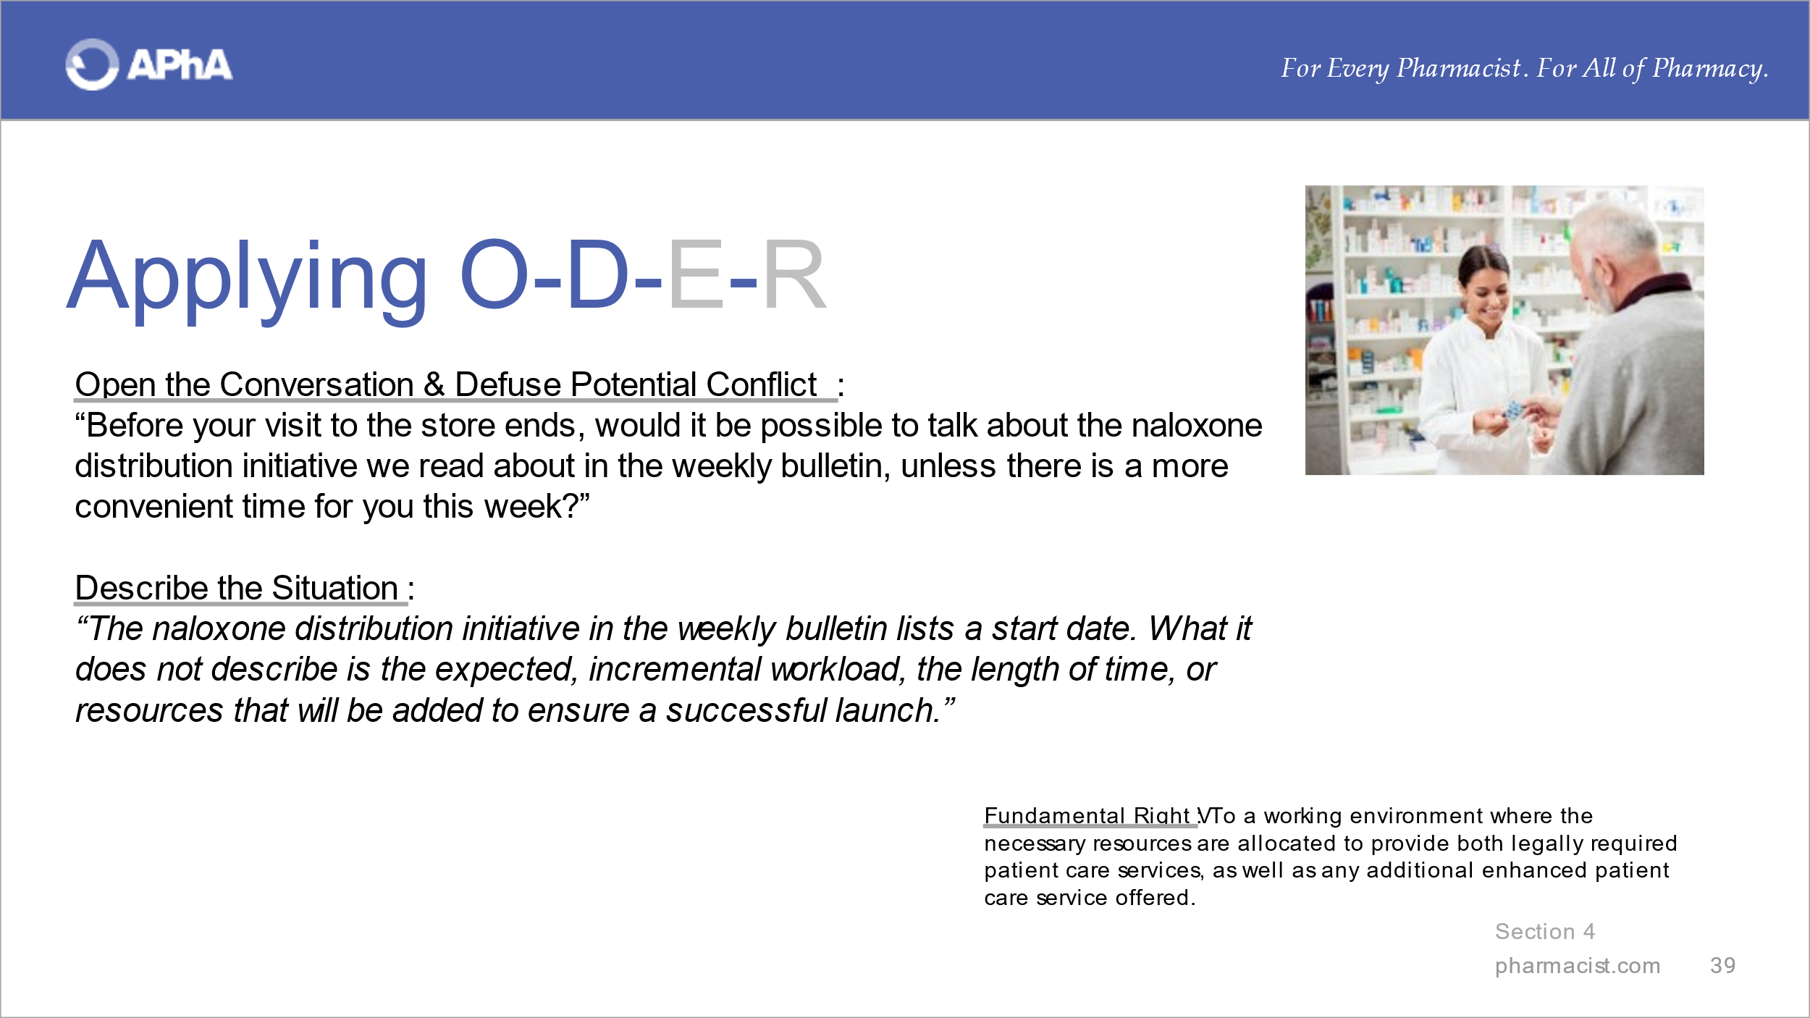
Introduce the second scenario and offer the example language to ‘Open the Conversation’ and ‘Describe the Situation’.
Ask whether learners can relate to this situation. Solicit alternatives to the example language offered from students for these two steps from learners.

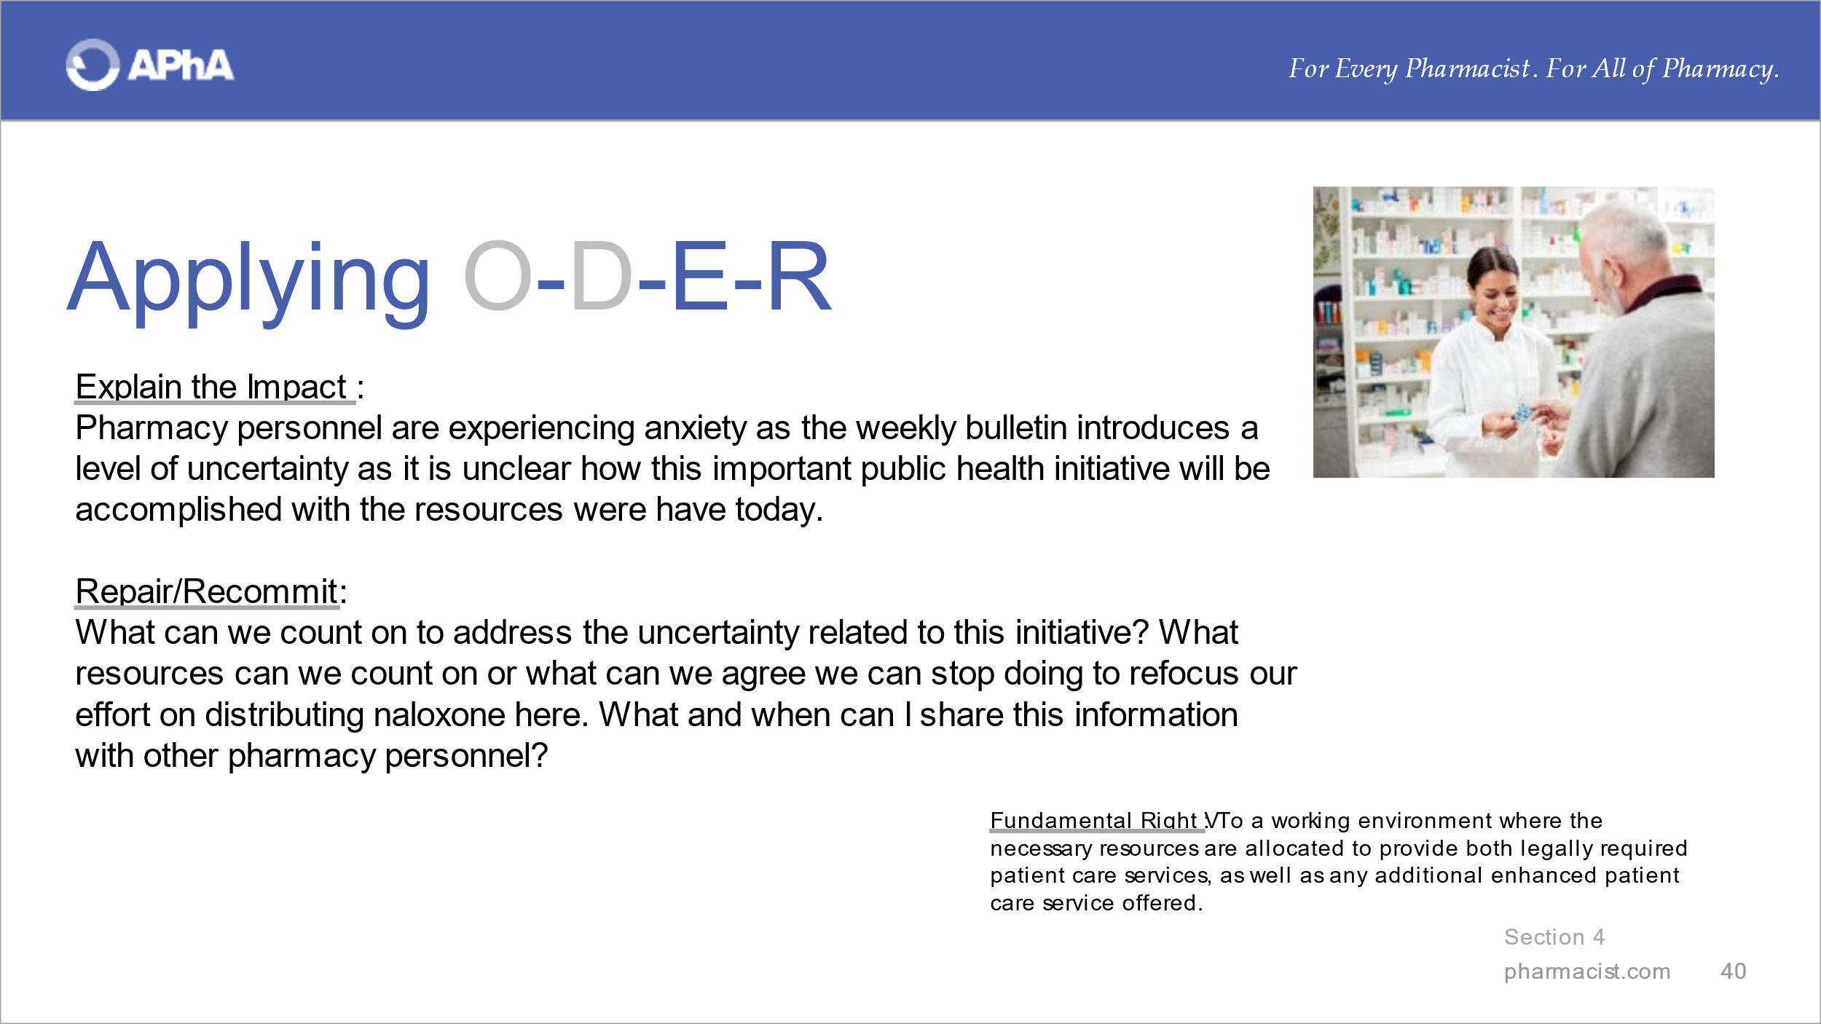
Offer the example language to illustrate “Explain the Impact” and “Repair/Recommit”.
Solicit alternatives to the example language offered for these two steps from learners. Inquire whether learners feel that this situation maps to other responsibilities/rights and why.

Scenario #3: “Technician & intern hours have been suddenly cut by 20% with no reason cited. This is to occur starting next week.”

This scenario maps to Fundamental Right V.

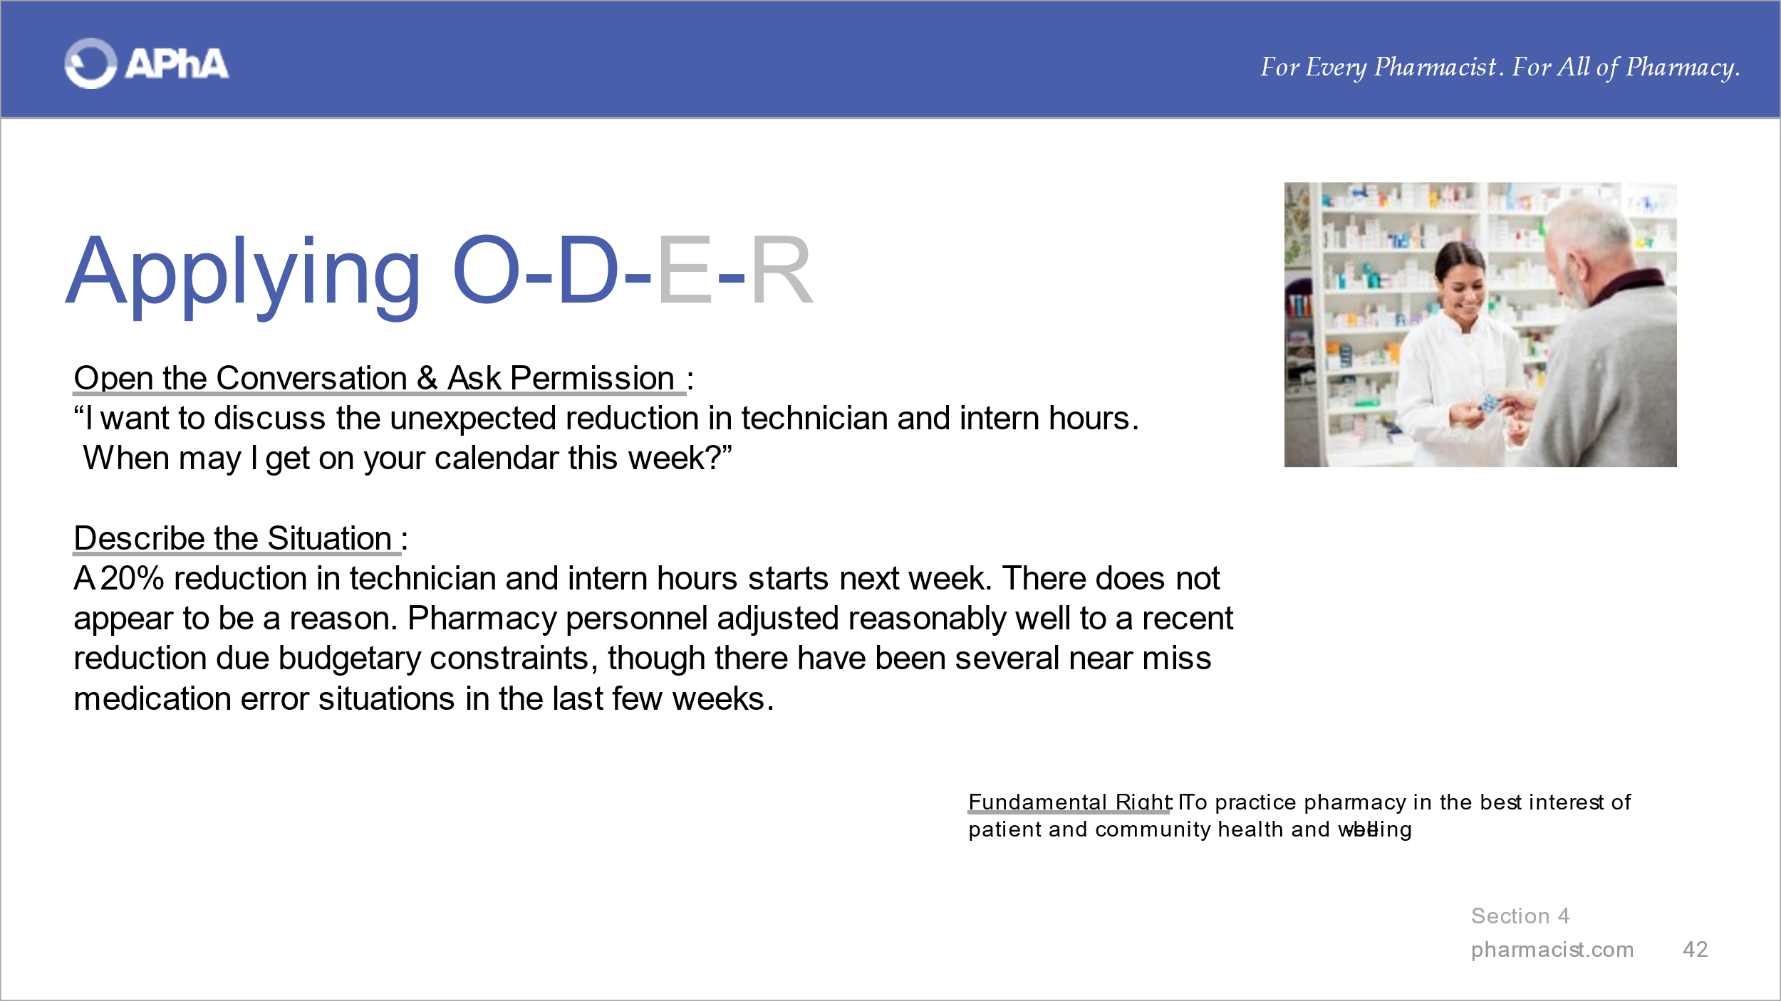
Introduce the third scenario and offer the example language to ‘Open the Conversation’ and ‘Describe the Situation’.

Ask whether learners can relate to this situation. Solicit alternatives to the example language offered for these two steps from learners.

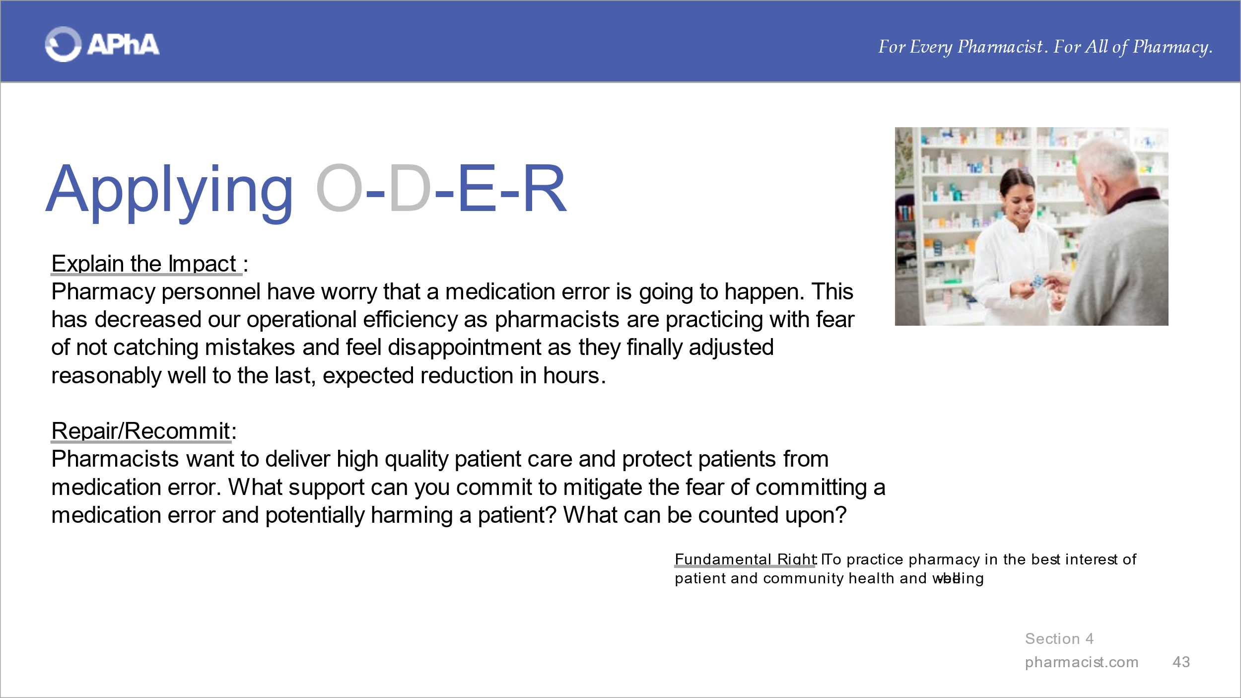
Offer the example language to illustrate ‘Explain the Impact’ and ‘Repair/Recommit’.

Solicit alternatives to the example language offered from learners. Inquire whether learners feel that this situation maps to other responsibilities/rights and why.

Section 4a. Considering Employment Opportunities

Engage learners in a conversation about what they can do to secure a position that is aligned to their professional and personal goals. Pharmacists and student pharmacists are best positioned to make informed decisions at the outset of an employment opportunity. Informed decisions can be made when time has been invested to know yourself well. Dream jobs don’t simply appear in most cases. In fact, it is likely that even dream jobs are not perfect. It is unrealistic to think that a job position will meet professional goals and personal needs and values 100% of the time.

Proceed to discuss with learners what is realistic.

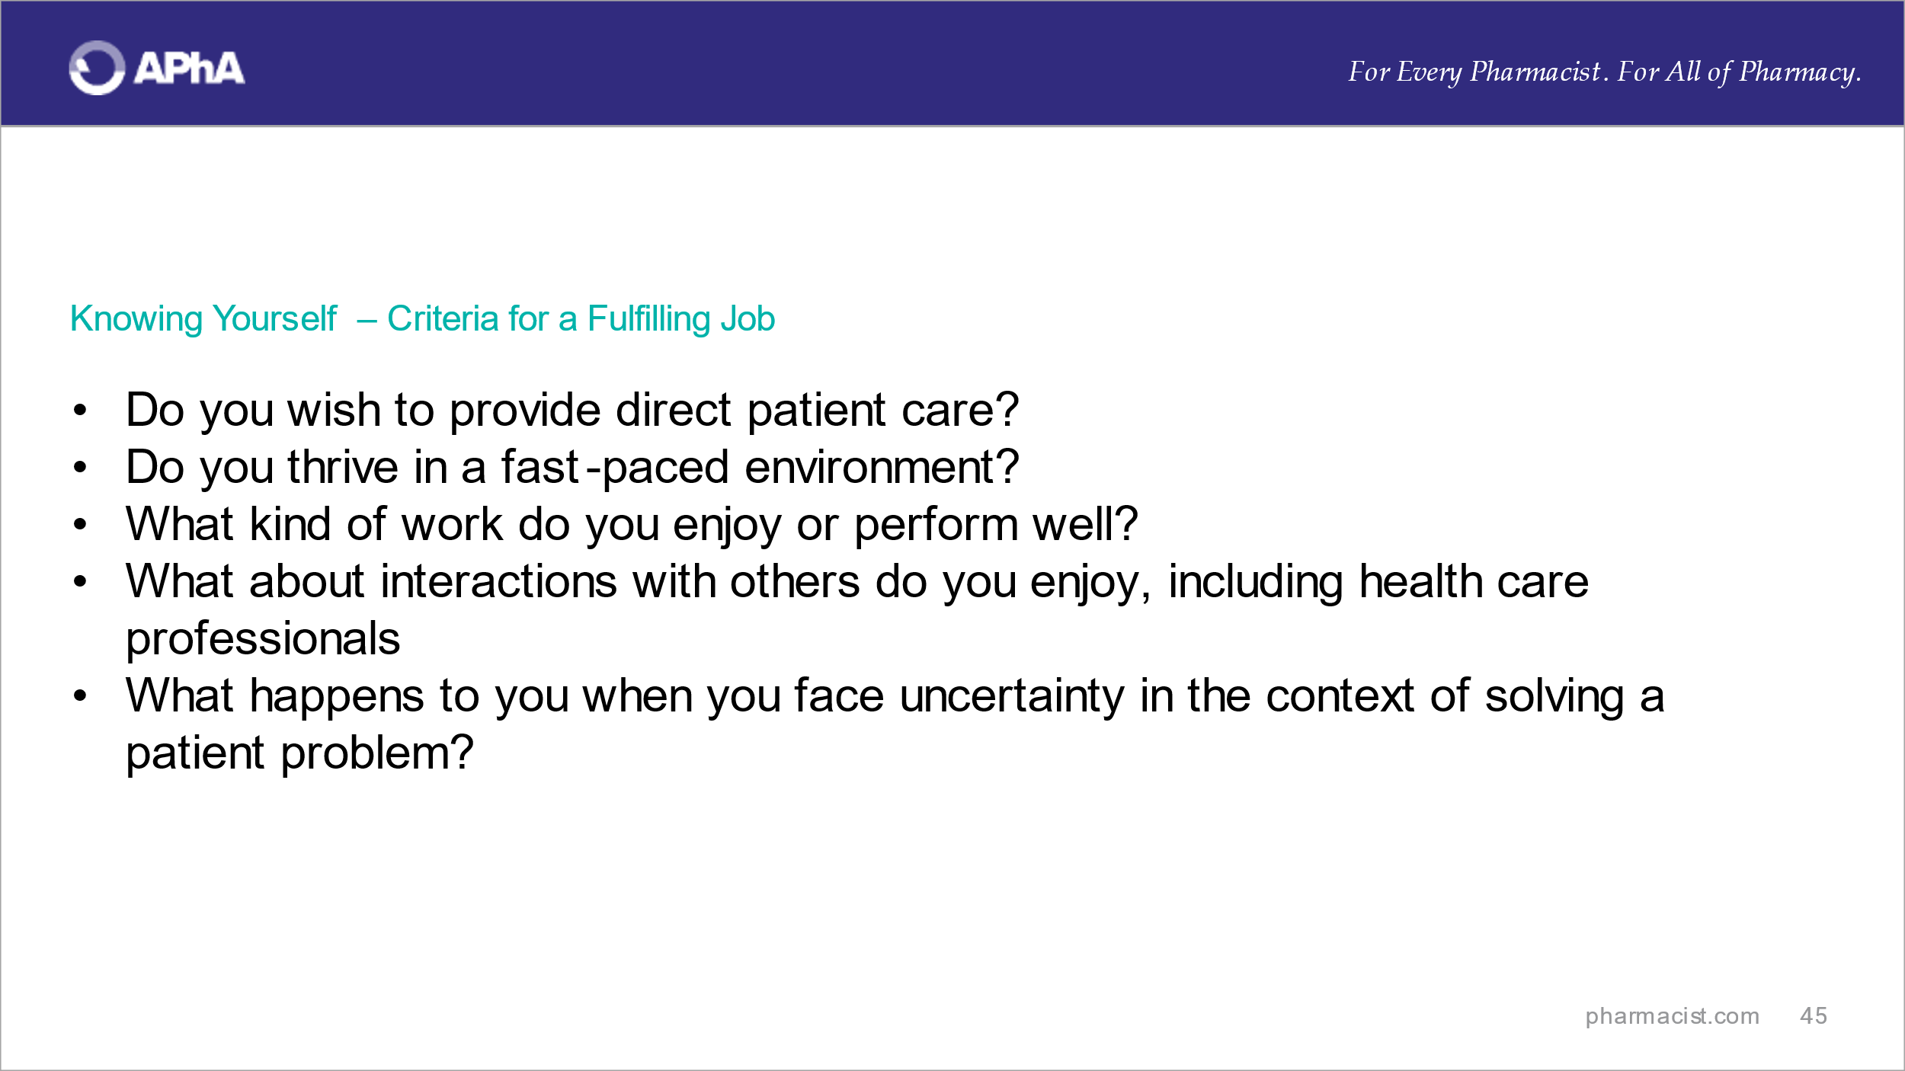
Emphasize that it is realistic to consider sufficient information to make a conscious decision. It is also realistic to be clear about elements that will be fulfilling in any job.
What are learner answers to the questions on the slides? What additional questions can they ask to understand what they think will be fulfilling in a job? Clarity will enable students to ask strong questions of a potential employer.

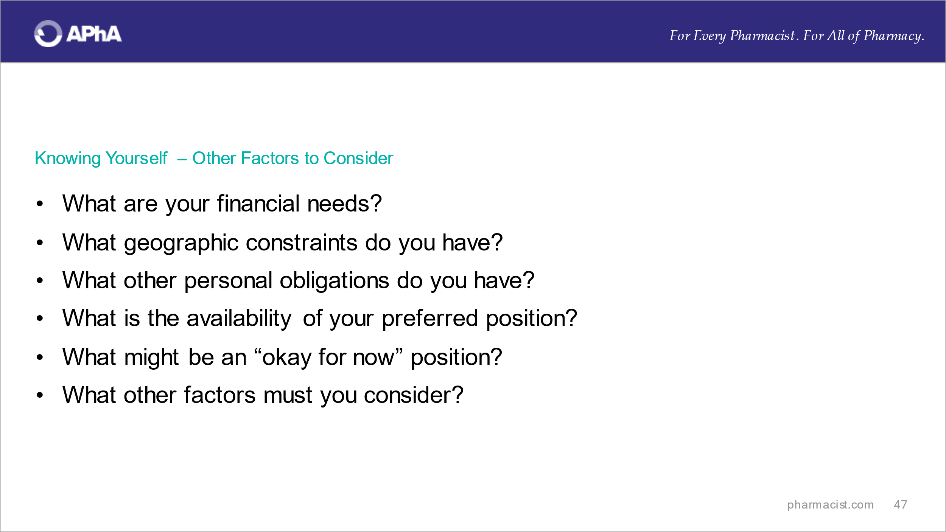
Convey that it is also unrealistic to think that professional goals are the only driving factors for employment decisions. Review the questions on the slides with the students? What additional questions can they ask and answer regarding other factors to consider?

Convey what “acceptable for now” means when factors must take a higher priority at the present time and that is okay.

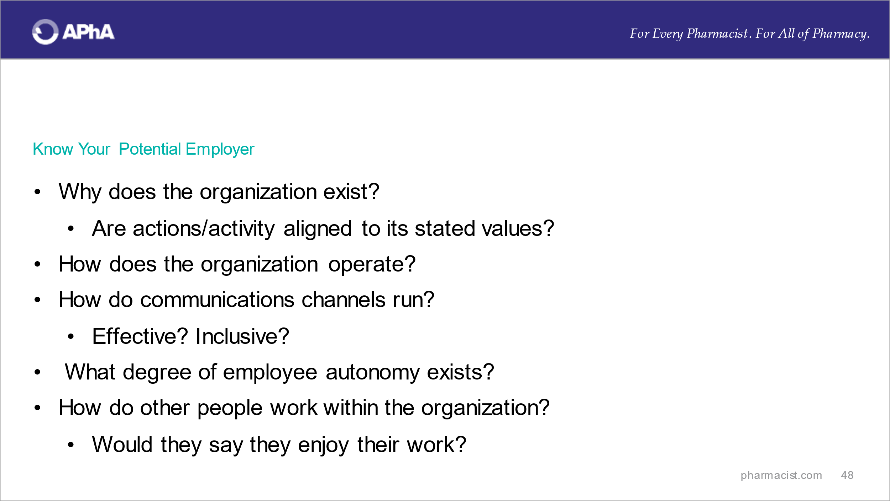
Emphasize to learners that it is equally important to know all they can about the prospective employer. The questions on the slide illustrate what information might be useful to know about a potential employer.
Review the questions on the slides with the learners? What additional questions can they ask to deepen their understanding of a potential employer?

Scenario #1: Changing positions and avoid being in the same situation

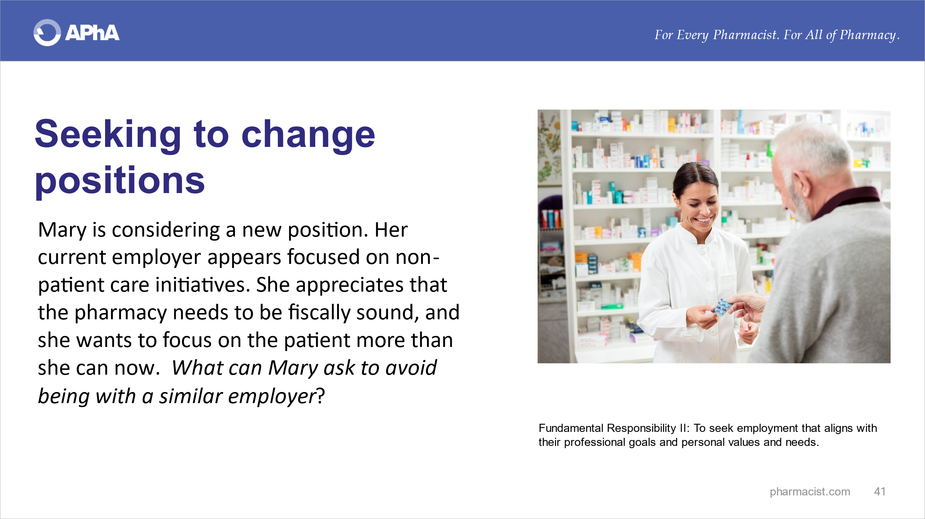
Review the situation about fictional ‘Mary’.
Engage learners in a discussion about what Mary can ask to avoid being with a similar employer.

After soliciting questions from students, review two examples of questions that ‘Mary’ could ask to gain additional information from a potential employer.

Scenario #2: Checking out a ‘dream’ job offer
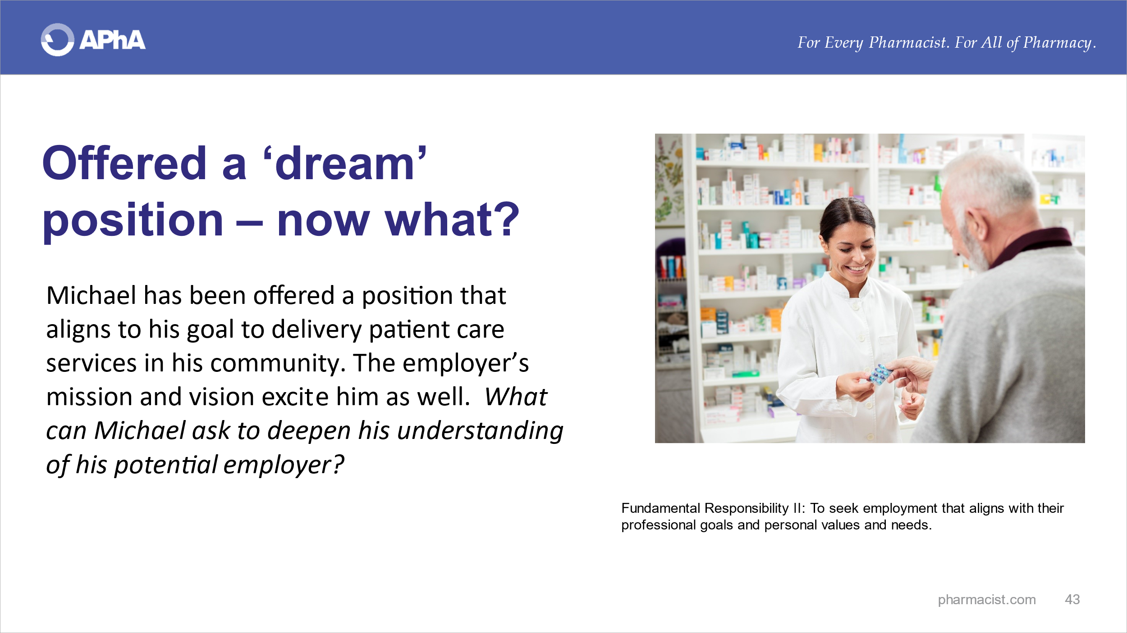
Review the situation about fictional ‘Michael’.
Ask students what additional questions ‘Michael’ can ask to supplement what he already knows so that he can be assured that the dream position is not “too good to be true”.

After soliciting questions from students, review two examples of questions that ‘Michael’ could ask to gain additional information from a potential employer

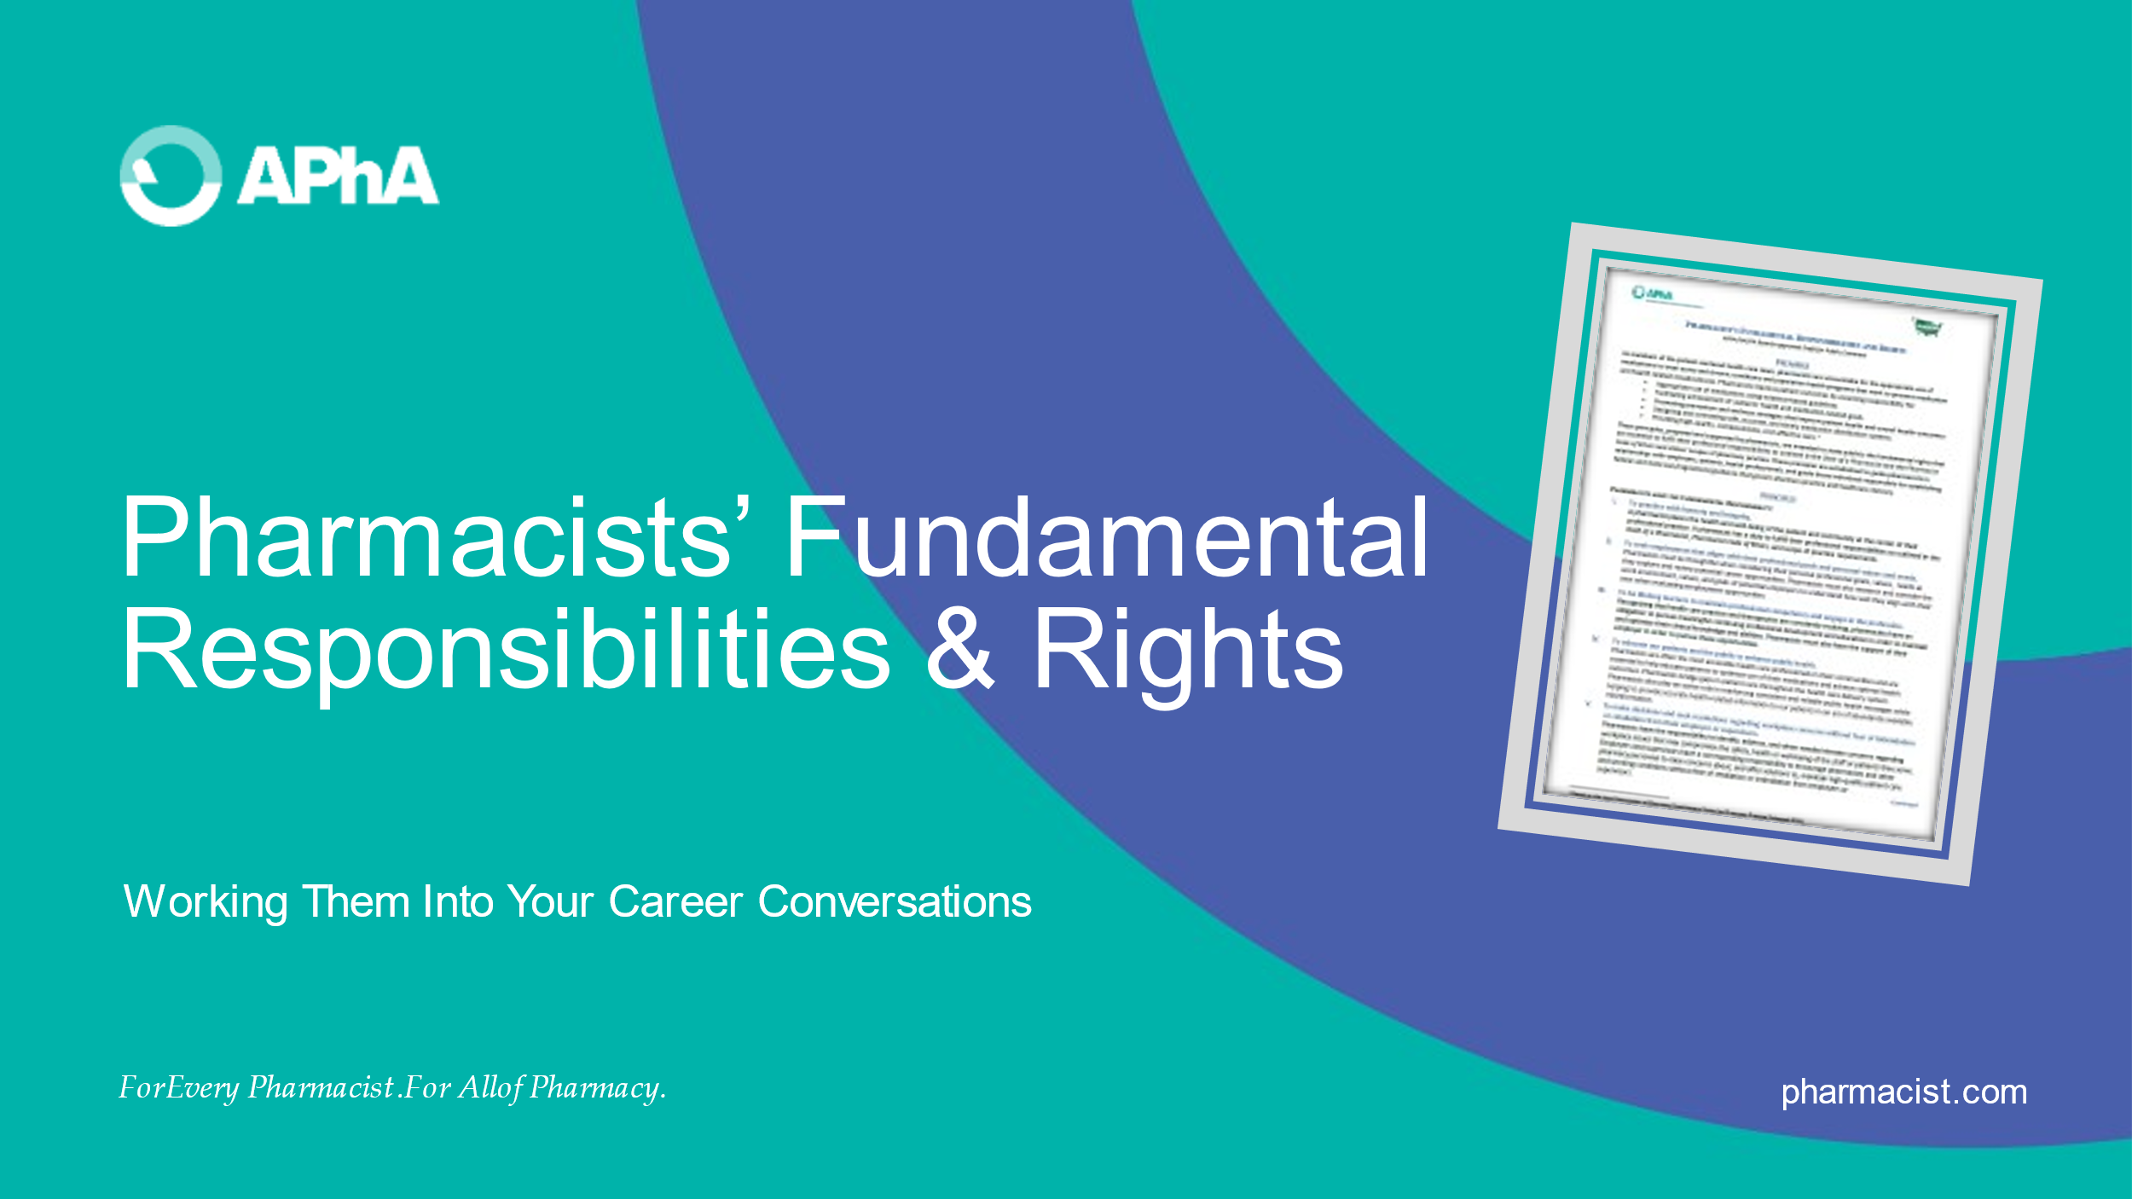
Summarize the information discussed with learners.

Encourage students to visit pharmacist.com for additional information and resources and to stay current with APhA’s initiatives, especially those related to the workplace.

<END>

